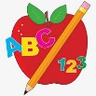 Primary 3 Homework
Week Beginning: 11th September 2023
Here is a guide to help you for this week. You can choose how to organise your tasks to suit what works for you.
Please bring book bags to school every day. They will be collected in on a Friday as there will not be any homework at the weekend. If you feel you want to continue some of the homework over the weekend please ask for your child’s book bag.
 | Literacy | Numeracy
 | Spelling  Please complete 2 active and 2 written spelling activities for your words.  Activities list on blog.  Woody, Buzz Lightyear and Little Aliens  earn children because earth  bread ready dead instead  pleasant pheasant weather feather  Rex  said could her before  bucket brain stair boy  royal road quick queen | Click on the Learning Intention to play the games.  LI – We are learning to identify numbers using place value.  https://ictgames.com/sharkNumbers/mobile/index.html  LI – We are learning to create numbers using place value.  https://ictgames.com/mobilePage/lifeguards/index.html  LI – We are learning to compare numbers.  https://www.sheppardsoftware.com/math/numbers/fruit-splat-compare/
 | Reading  LI – We are learning to be fluent readers.  Woody  Tricking Our Eyes  Buzz Lightyear  Martial Arts  Little Aliens  My Life  Rex  Make an Egg Card | Find numbers at home and compare them.  Listen to the hungry alligator to recap comparing numbers.  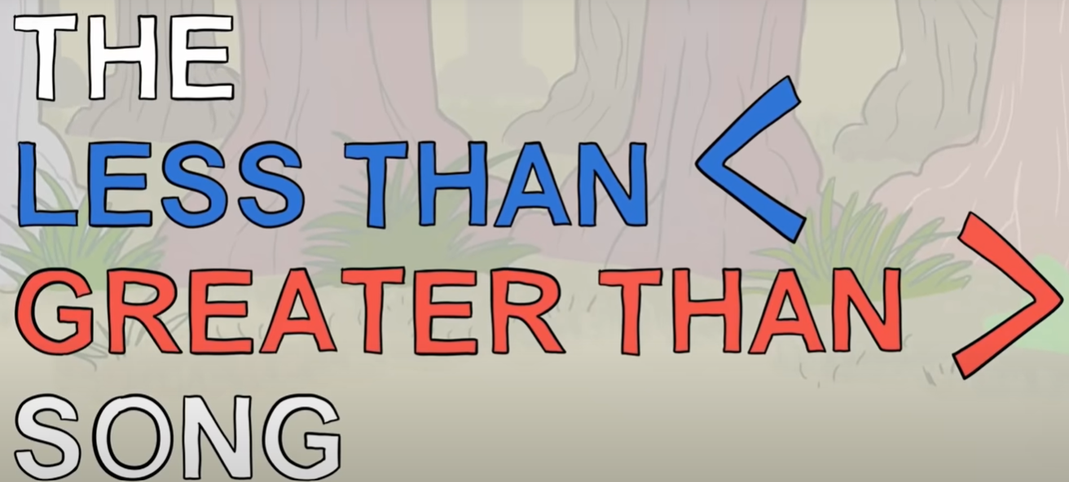  *Order the numbers you find.
Remember to have lots of fun!

