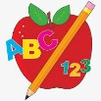 Primary 3 Homework
Week Beginning: 4th September 2023
Here is a guide to help you for this week. You can choose how to organise your tasks to suit what works for you.
Please bring book bags to school every day. They will be collected in on a Friday as there will not be any homework at the weekend. If your feel you want to continue some of the homework over the weekend please ask for your child’s book bag.
 | Literacy | Numeracy
 | Spelling  Please complete 2 active and 2 written spelling activities for your words.  Activities list on blog.  Woody, Buzz Lightyear and Little Aliens  gave family how might  write wrist wrote wrong  wrinkle wreck wrap written  Rex  are come of new  wheel whisk phoneme elephant  green need mood spoon | Click on the Learning Intention to play the games.  LI – We are recapping our number bonds to 10, 20 and 100.  LI – We are learning to identify numbers using place value.  LI – We are learning to create numbers using place value.
 | Reading  LI – We are learning to be fluent readers.  Woody  Dino-Splashing  Buzz Lightyear  Brave Little Beasts  Little Aliens  Scaredy Cat  Rex  Look Outside | Identify numbers in your environment when walking to and from school.

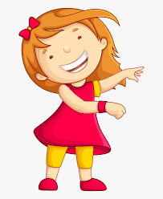Remember to have lots of fun!

