We have included a timetable below should you wish to record when and what types of homework your child should routinely receive, as a reminder. Please appreciate that there may be instances when this may change during the session.

Monday

Tuesday

Wednesday

Thursday

Friday

Additional Information

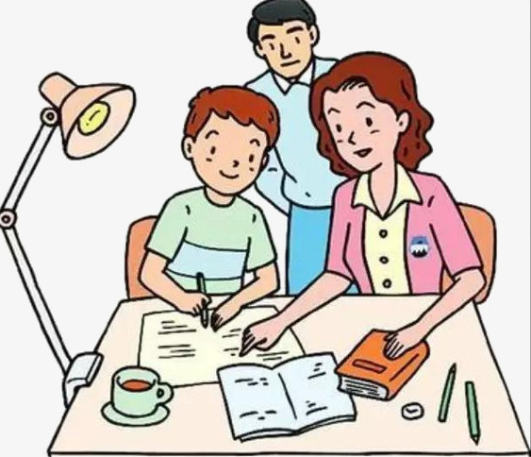

Homework – Supporting Learning at Home
A better way to describe homework might be 'learning at home’. Children learn a great deal at school, you can add to that learning by supporting them at home with reading together, writing and counting. In Drongan Primary School, homework plays an important role in the learning and teaching of Curriculum for Excellence.
Showing an interest in homework and talking to your child really helps them to learn. With support and encouragement, children find it easier to get into the homework habit, take more responsibility and learn how to organise and manage their time.
Homework is learning that children do for themselves, perhaps with the support of parents/carers or other family members such as grandparents or older brothers/sisters. In Drongan Primary School, this partnership is very important and is further developed through our Enterprise homework tasks. The process involved in these tasks, between parents/carers and the pupils, is sometimes more important than the end product itself.
Children can find homework interesting and fun – or dull and annoying. However, doing homework is important – it makes a difference to learning. Knowing how to get involved in ways that work for you and your child can really help.

Who is involved?

Homework can be helpful or it can be a source of stress; however, homework arrangements work well when the school, the individual teacher, the parent and others in the family, and the pupil understand the roles each of them can play.

The pupil's role can be to:
- keep a note of what is required and when it is due
- plan ahead
- make the time to do the homework
- look for help when stuck or frustrated
- hand in completed homework on time.

The parent's role can be to:
- encourage your child
- talk with your child about what they are learning
- listen to worries
- get in touch with the school if you have concerns

The school's role can be to:
- let you know what is expected of your child
- let you know who to contact if you are concerned.

The teacher's role can be to:
- set homework which is interesting and at the right level
- clearly explain the purpose of the homework to pupils
- keep aware of other pressures and responsibilities pupils might have
- set realistic deadlines
- check on homework and give feedback
- give recognition for effort and work well done.

What can Parents/Carers do?

When children are younger, parents may be actively involved in helping them learn specific things such as spelling and counting. As your child progresses through school, the things they learn will become more complex and homework may become more demanding.
Young people also become more independent as they grow older and may not want parents to know what they are doing or to offer help.
We all know that homework can be a source of tension and argument in the home for a number of reasons. Even if you do not know much about the subject, you can offer support in different ways:
- encourage your child to talk about their learning
- give praise by acknowledging their successes in this way supporting our certificate recognition in school
- if they need support, encourage your child to think about how they can find answers for themselves.

Further information to support your child’s learning at home can be found at:

https://education.gov.scot/parentzone

Our digital homework guide can be found on the school blog at:
https://blogs.glowscotland.org.uk/ea/dronganpsecc2016/homework/
Class Homework Guides
The following information is aimed at providing you, the parent/carer, with an understanding of the homework routines for your child’s class throughout the school session.

Enterprising Homework Activities
During the session our pupils will be involved in whole school enterprising homework activities. These activities are designed to enable pupils and parents to work on an enjoyable activity together to stimulate discussion about the pupils’ learning. Parents should not feel under any pressure the emphasis is on enjoyment and fun working together to complete a simple project.

P3

Frequency & Type of Homework Issued:
Spelling homework will be issued on a Monday, to be returned on a Thursday.

Maths homework will be issued on a Monday, to be returned on a Thursday.

Reading homework (Bug Club) will be issued on a Monday to be returned on a Friday.

Any topic, science or HWB tasks will be issued on a Monday to be returned on a Friday (unless stated otherwise).

After having discussed it in class on a Monday, all pupils will be responsible for accessing their homework planners on the ‘Homework’ tab on the P3 class blog (linked). https://blogs.glowscotland.org.uk/ea/missdyce/homework/

PE will take place on a Monday and Wednesday, so please remember to bring PE kits on these days and be aware jewellery should not be worn during PE.

Routine & Expectations: e.g. parent participation:
Parents are encouraged to help their children with their homework (especially bigger tasks and reading).

Active & Enterprising Homework:
At least one large piece of homework will be issued per session, usually relating to topic work or whole school initiatives. These enterprise homework tasks should involve parents.

Additional Information:
Homework diaries are designed to aid parents with all tasks. Where appropriate, children will take responsibility for filling in their homework diaries themselves.

