P4/5 Homework Activities
Week Beginning: 20/01/2025 Monday – Thursday
Try to work on some homework tasks each night. You can fit them in around your family schedule. Return your jotters to school on a Friday please.
SPELLING : Phoneme –ou
Spelling Test in class for this week’s spelling words.
Griffin & Phoenix | Dragon | Nessie
disjointed  disappoint  pointed  poison  noisy  joined | soil  voice  moist  foil  toilet  join | boy  toy  joy  soy  enjoy

- Look at the spelling words for your group, copy each word 3 times.
- Choose 5 of words from your list, write 5 sentences using a capital letter, full stop. Try to include an adjective( decribing word) .
EXTRA: Try some different activities from the grid below to help you too.

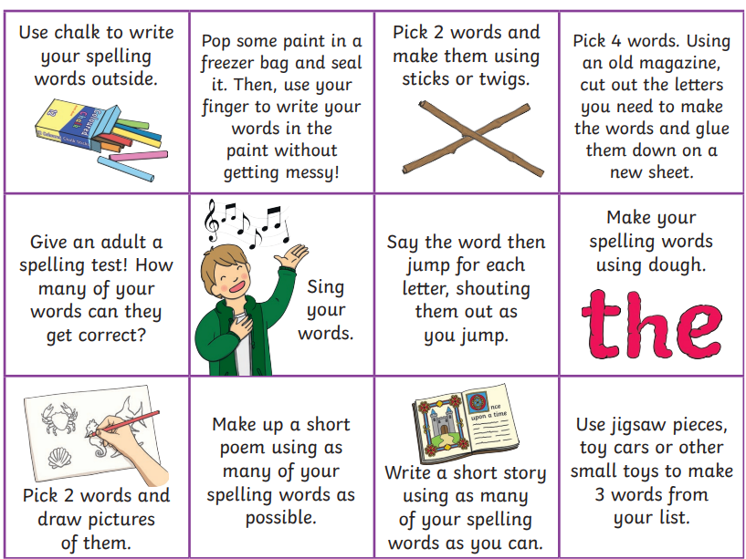

READING & COMPREHENSION -
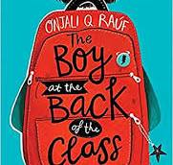 We are starting our RME novel study this week. Reading books will still be changed every two week but the focus for comprehension will be our novel. Listen to the first chapter here:



Numeracy:

This term we are looking at the skills involved with multiplication and division. Have a practise at your times table skills below:

The Puddock 

We have given out our scots poem in class. This year we will be practising ‘The Puddock’ by John M Caie. Have a practise at home and watch the following video to help you.

https://www.youtube.com/watch?v=FHzx6nso59w



