**P4/5 Homework Activities**

**Week Beginning: 24/09/24**

**Monday – Thursday**

Try to work on some homework tasks each night. You can fit them in around your family schedule. Return your jotters to school on a **Friday** please.

**SPELLING : Phoneme –(ee sound) ie, e-e**

**Spelling Test in class for this week’s spelling words.**

|  |  |  |
| --- | --- | --- |
| **Griffin & Phoenix** | **Dragon** | **Nessie** |
| **thief**  **these**  **complete**  **mischief**  **shriek**  **relieve**  **niece**  **believe** | **He**  **thief**  **these**  **me**  **believe**  **here** | **Sea**  **Pea**  **Flea**  **Tea**  **Please**  **Speak**  **Weak** |
|  |  |  |

1. **Look at the spelling words for your group, copy each word 3 times.**
2. **Choose 5 of words from your list, write 5 sentences using a capital letter, full stop. Try to include an adjective( decribing word) .**

**EXTRA: Try some different activities from the grid below to help you too.**

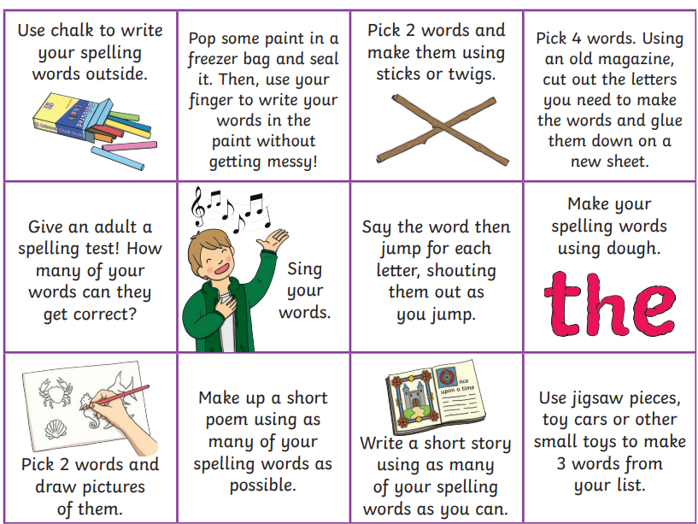

**READING & COMPREHENSION** 

**Bugclub Books- please read the allocated class book. You can do this with an adult or a sibling. Spread the reading over the 2 weeks and practise fluency and expression. Try to look for different punctuation marks, speech marks. TALK about the book with someone in your household. Did you like it? Favourite part? Did you learn any new vocabulary?**

**\*Griffins will get a new book on Tuesday.**

**NUMERACY**

This week we have been focusing on partitioning 4/5/6 digit numbers.

Try the ‘Partitioning’ Challenge on the Daily 10 quiz. You can choose the level of difficulty to suit your child.

