Sound of the week | Common words | Reading | Writing | Maths/Number | Science/HWB/Art | Topic
sh, ch,th,ph  Get a large piece of paper and write each of these sounds at the top of the page. Think of as many words as you can with these sounds and write them under the correct heading. Set yourself a time limit for this. | Practise any common words you find tricky or haven’t practised in a while. | Allocated bug club book. | Make a digital card/picture or write a letter to your P7 Buddy. Miss Davidson and Mrs Mackie have been telling me that your buddies have been asking after you and thought it would be a nice idea for you to send them a letter or picture to say thank you. If you upload your letter or picture to your blog, we will make sure they are passed on. | Pirates change to 20p worksheet. | Design a pirate using leaves and flowers either from garden or from a walk. | Make an origami paper boat with flag.  https://www.youtube.com/watch?v=owx_MH2BZpk

Sound of the week activities
See attached outdoor spelling cards. Activities can be used for both spelling words and common words.

Common words
Can you please help your child learn to recognise these words by writing them (bubble writing, colourful writing, squiggly writing, fancy writing) or with materials outside. Drawing a line around each word and looking at the shape of the word. Talking about tall and small letters. You can use your magnetic letters to say, make, read and write these words.

Sounds
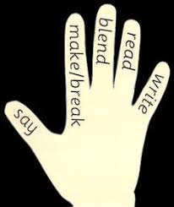
Say, make, break, blend, read and write using words from the list. Your child will be able to tell you what to do!
Don’t show your child the word, just say it to them. Use the magnetic board.

