Sound of the week | Common words | Reading | Writing | Maths/Number | Science/HWB | Topic/Science
oy  toy  enjoy  royal  cowboy  loyal  Can you think of any other oy words?  oy crossword – you may need some help from an adult with this as some words are a bit tricky but I am sure you can manage with a little help! | our  down  off  Practise making these words with your magnetic boards and using them in a sentence. | Allocated bug club book.  Word search for topic words.  Complete a book review for one of your allocated books. | Pirate message in a bottle  Powerpoint and writing activity. Details are included in powerpoint and attachments. | Information Handling  I can collect objects and gather information, organising and displaying my findings in different ways.  https://www.bbc.co.uk/bitesize/clips/z7r9jxs  https://www.bbc.co.uk/bitesize/clips/z4nyr82  Carry out your own transport survey using the worksheet provided then use your tally marks to create a bar graph (worksheet provided) and answer the questions. | Pirate puppets for role play | Design a ship flag  Confusing Cans experiment (P12 – 15 of STEM pack attachment.

Sound of the week activities
See attached outdoor spelling cards. Activities can be used for both spelling words and common words.

Common words
Can you please help your child learn to recognise these words by writing them (bubble writing, colourful writing, squiggly writing, fancy writing) or with materials outside. Drawing a line around each word and looking at the shape of the word. Talking about tall and small letters. You can use your magnetic letters to say, make, read and write these words.

Sounds
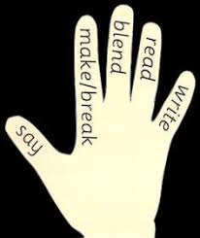
Say, make, break, blend, read and write using words from the list. Your child will be able to tell you what to do!
Don’t show your child the word, just say it to them. Use the magnetic board.

