Sound of the week | Common words | Reading | Writing | Maths/Number | Health | Topic
ee  see  been  seen  three  green  sleep  keep  need  feel  deep | had  see  has | BugClub – read and your non-fiction bug club book and write or draw two new facts you have learned.  Read a book with an adult and talk to them about the beginning, middle and end. | Make up your own story with a beginning, middle and end. Draw or write it for someone to read. | Either indoors or outdoors, make a numberline and challenge members of your family to solve calculations with you.  Make patterns using numbers, lego bricks, objects or letters.  Practise number and letter formations outdoors with chalk or water and brushes. | Take a safe family walk and throw stones in the river.  Try a new healthy food/snack that you are not familiar with and describe what it tastes like.  Draw or create a spring picture either indoors or outdoors.  Choose one task from the mindfulness challenge cards to complete. | Our new class topic is going to be Pirates.  Your task this week is to find three interesting facts about Pirates that you didn’t know already.

Sound of the week activities
See attached outdoor spelling cards. Activities can be used for both spelling words and common words.

Common words
Can you please help your child learn to recognise these words by writing them (bubble writing, colourful writing, squiggly writing, fancy writing) or with materials outside. Drawing a line around each word and looking at the shape of the word. Talking about tall and small letters. You can use your magnetic letters to say, make, read and write these words.

Sounds
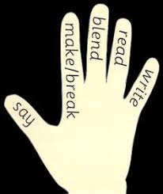
Say, make, break, blend, read and write using words from the list. Your child will be able to tell you what to do!
Don’t show your child the word, just say it to them. Use the magnetic board.

