Amazing Fact
In Elizabethan times, it was fashionable for women to make their teeth black. Sugar was a new ingredient in Britain and was causing teeth to turn black and decay. As sugar was so expensive, making your teeth look black showed that you were rich enough to buy it.

Challenge
How would you explain to someone else how they need to clean their teeth?
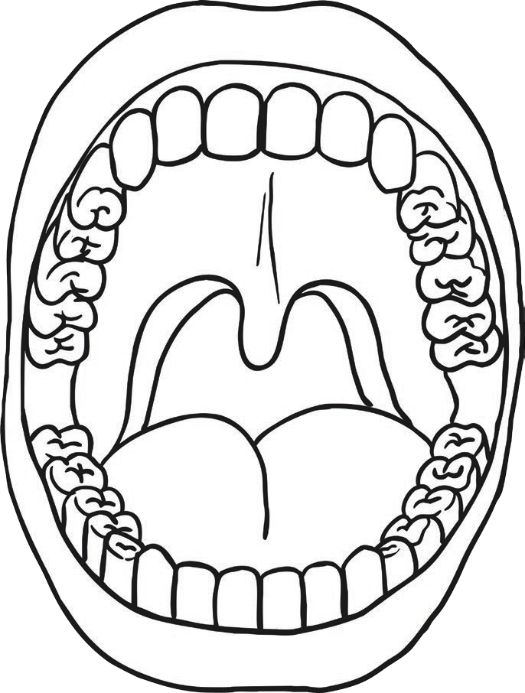Use the writing frame on the following page to draw and write four stages of cleaning your teeth.

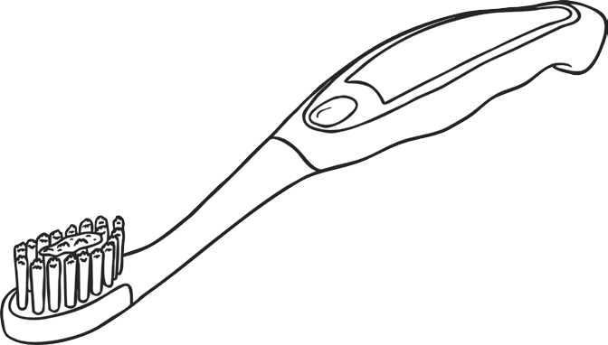

You could also try to find out:
- about other Elizabethan fashion trends;
- where sugar came from;
- how sugar is grown.

