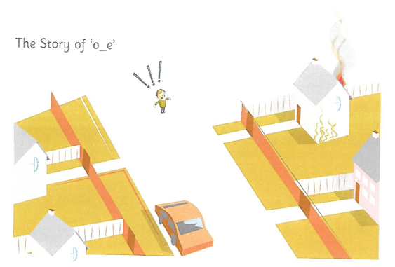

Ben was coming home alone from the store. Just before he turned into his own street he saw smoke coming from a house built of stone. Ben ran through a hole in the fence and knocked on the door. Just as he had hoped, the house owner phoned the Fire Brigade.
“You are a hero,” she said. However, when Ben got home, Belle did not believe him! Ben said, “It is not a joke!”

