Fractions
- What fraction of the pizza is left on each plate?
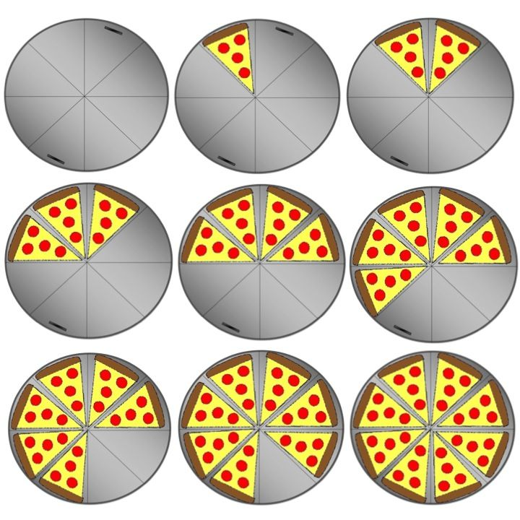1. 2. 3. 4. 5.
6. 7. 8. 9.

- Find one tenth () of each amount: (e.g. of 90 is 9. You can find a tenth by dividing by 10.)
- 40 b. 80 c. 70 d. 120
e. 160 f. 250 g. 340 h. 1300

- Find:
- of £1 = b. of £5 = c. of 50p =
d. 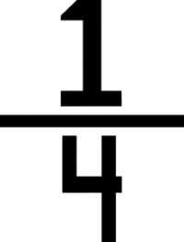 of £1 = e. of £10 = f. of £20 =

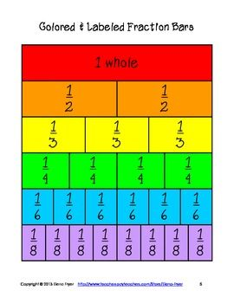
- Find the equivalent fraction (e.g. = 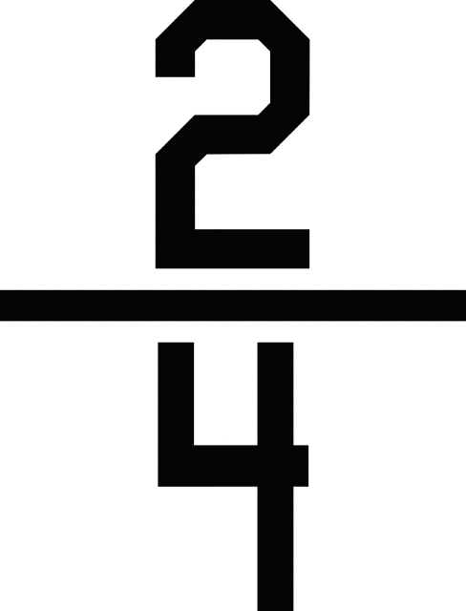 )

- 1 = __ b. 3 = ___
3 6 6 8

- 4 = __ d. 6 = ___
8 2 8 4

