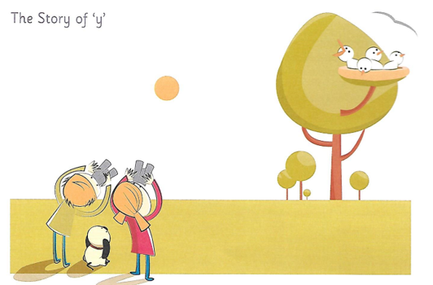

One day Ben, Belle and Dasher were looking up at the sky through their binoculars.
“Look!” said Ben. “I saw a bird fly up to its nest.”
“Why yes! I can see it too,” said Belle. “We can look at the sky for a while and try to see the bird’s babies in the nest.” Soon the bird came back with food in its mouth.
“See how the baby birds cry for their dinner,” said Belle.

