Special events this week:
- National Cake Day: A day to celebrate all things cake, from baking your own to just enjoying a bought cake.
- Remembrance Day: What is it and why is it important? - BBC
Click to go to Newsround where you can read about this.
In Active Literacy we will be learning to read, write and spell different ways to make the short a sound.
Here are some ways to make the sound we are learning. Ask an adult to listen as you read the words from the lists and have fun challenging each other to spell some of them.

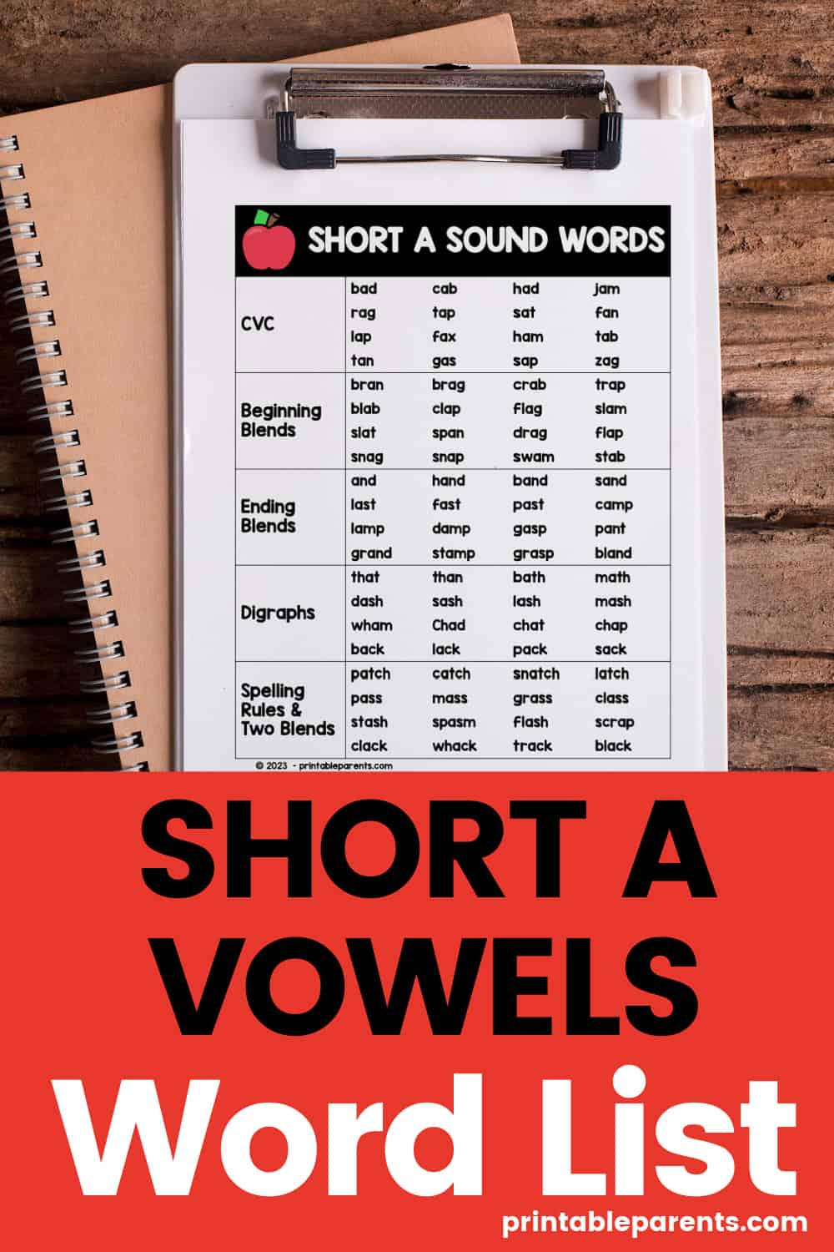
We are having a BIG push with reading and everyone has a guided reading book home. Please ensure your child reads this regularly and continue to read from MyOn as well. There are quizzes to complete with most books and children should let me know if they have earned a disc for the school display. Well done to those who have already added to this!

Numeracy
We have been learning about decimal numbers in class.

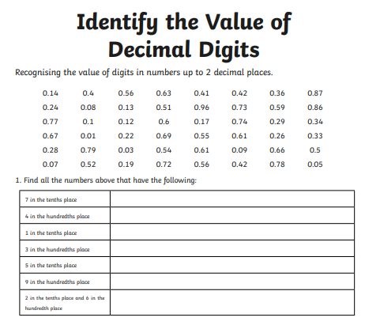

Write your answers in your Home Learning jotter. Good luck!

