Special events today:
- National Pumpkin Day: A day to celebrate the humble pumpkin.
- Steve Irwin Day: Celebrating the life and legacy of the famous Australian wildlife presenter.
In Active Literacy we will be learning to read, write and spell different ways to make the long a sound. Have a look at the following video clip to refresh your memory:
https://share.google/pfEmZbCKlYeNwePyk

Here are some ways to make the sound we are learning. Ask an adult to listen as you read the words from the lists and have fun challenging each other to spell some of them.

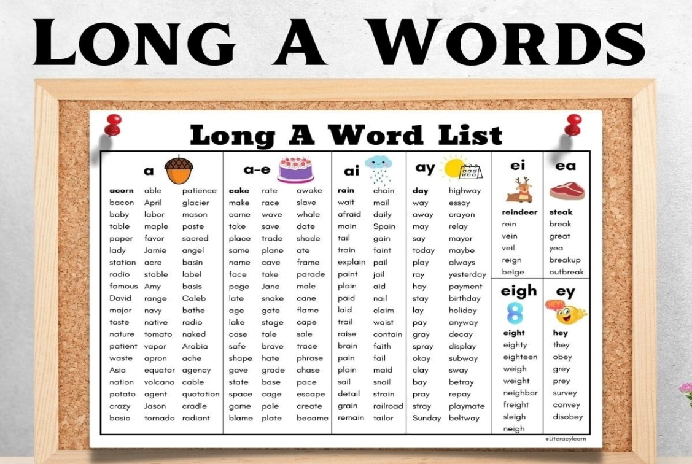

Numeracy
We have been learning about decimal numbers in class. Here is a video clip to watch and help you with your learning:
https://youtu.be/KrAQneGhyuE

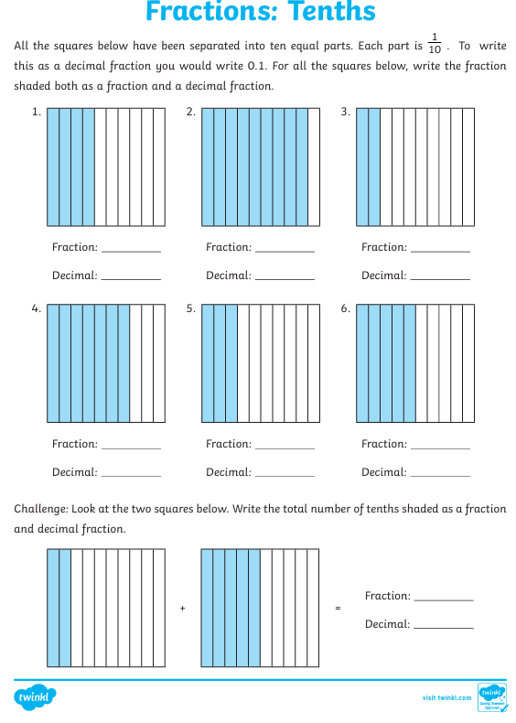
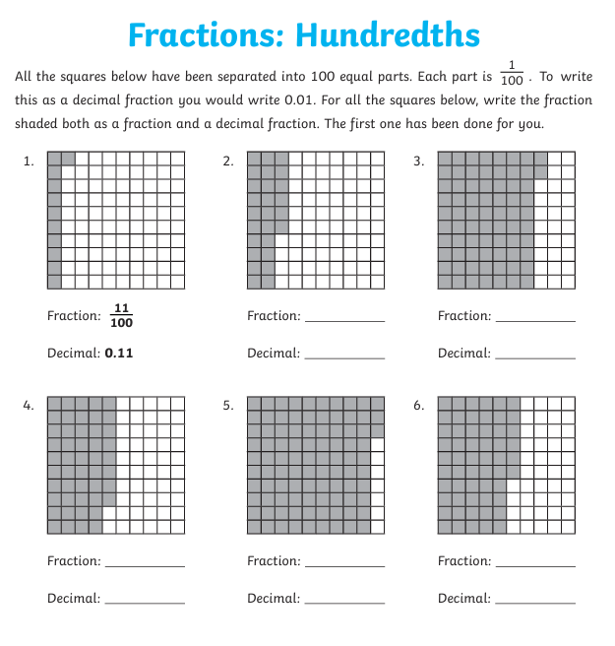
Write your answers in your Home Learning jotter. Good luck!

