Numeracy  Sumdog  I have assigned practice games for 12 and 24 hour time. Please complete.  https://play.sumdog.com/student/sign_in  Reading  Login to MyOn or with your personal reading book, spend 10-15 minutes a night reading. | Literacy- Prior Knowledge and Prediction  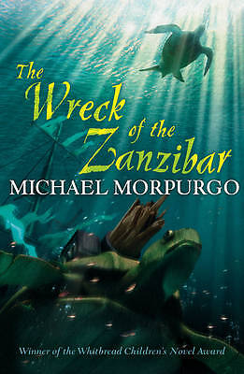  Using the front cover of the picture of book above create 6 predictions about what you think is going to happen in the book.  Remember to use your prior knowledge skills and clues from the front cover in your predications. | HWB- Dangers of Smoking and Drugs  As you have been learning about the dangers of Smoking in class please create a poster detailing the effects smoking has upon our bodies.  Nessy  If you access Nessy please spend 30 minutes over the course of the week playing it.
 | Primary 6– Week Beginning 17th February

