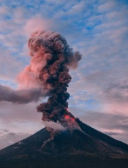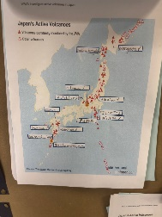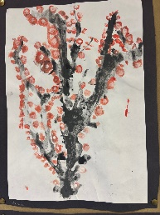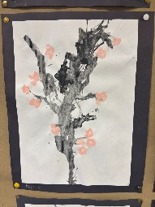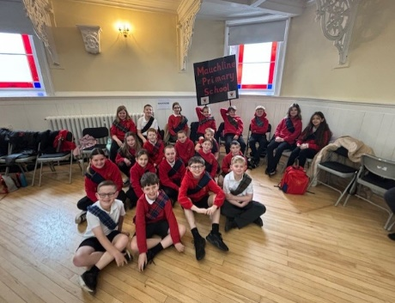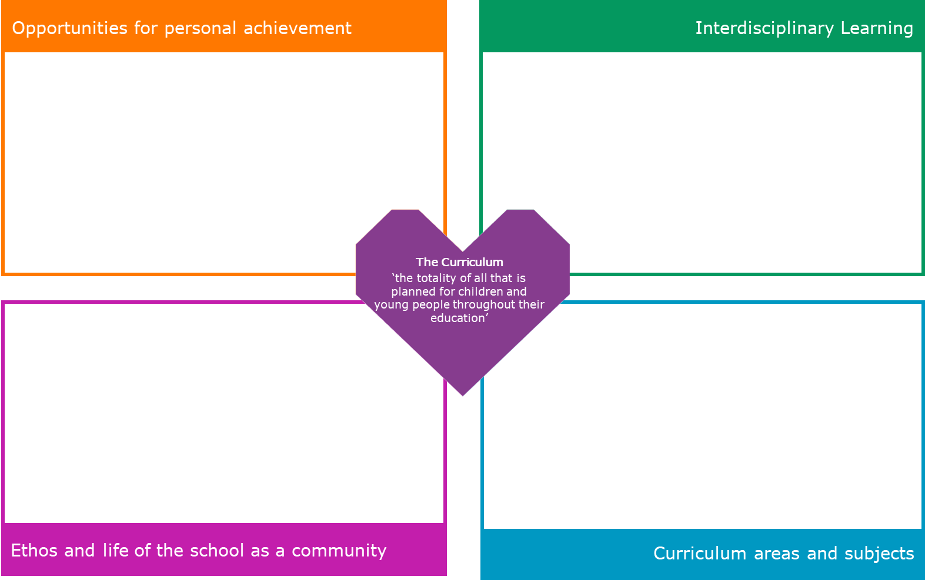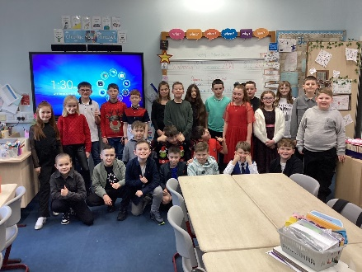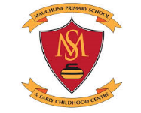

We have been researching the natural environment in Japan and we created some Cherry Blossom Tree artwork.

We have also investigated all about Volcanoes as part of Japan. We linked this to our knowledge about materials and gases from our Science topic in Term 1.

Primary 6s are continuing to act wellbeing champions and anti-bullying ambassadors in the playground. A rota has been set up so new champions are selected every week.

Primary 6 represented the school at the annual East Ayrshire Day of Dance. They had a fabulous time showcasing their Scottish Dancing Skills to the community in Cumnock.

Literacy – Explanation- How a volcano erupts, linking to our Japan topic.   
French- French Christmas Traditions.   
Numeracy and Maths- As part of our Money topic we set up our own party planning business to determine if we would could make a profit.   
PE- Dancing  
Health and Wellbeing- Paths, anti-bullying, Children’s Rights, Food and Health

Primary 6 took part and performed in our annual Christmas Sing-along. They performed Last Christmas and Merry Christmas Everyone.