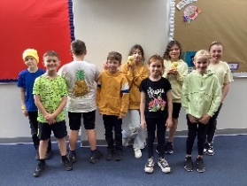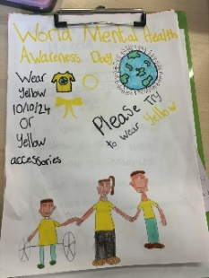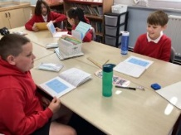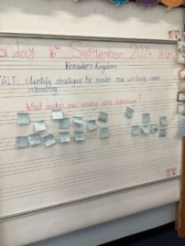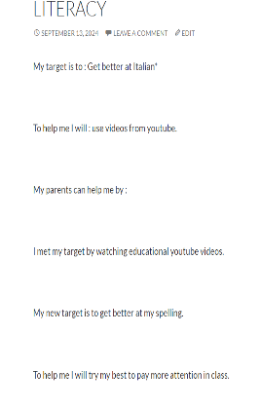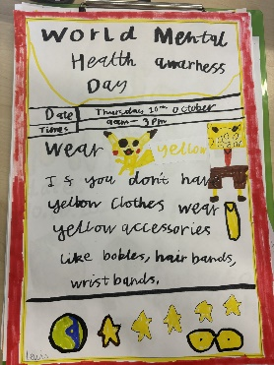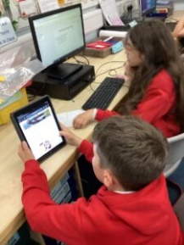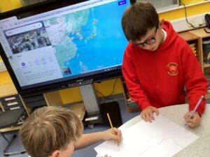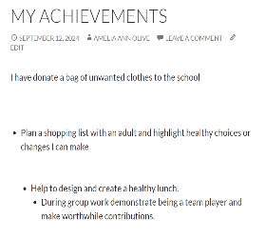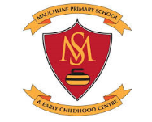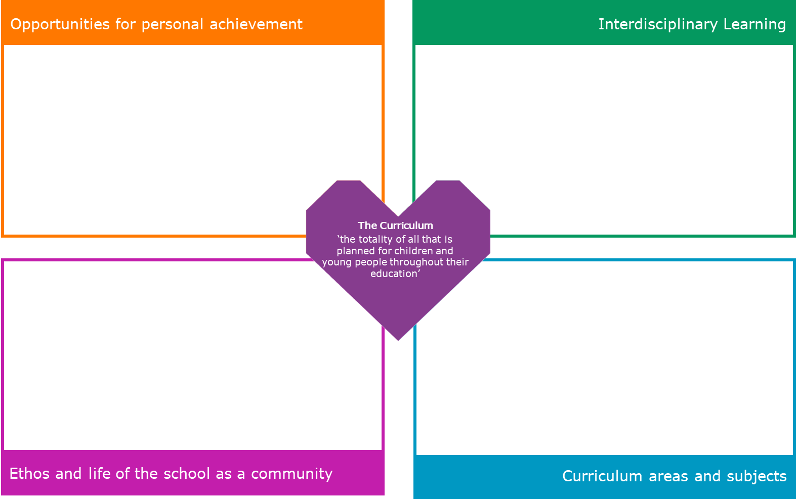

Literacy Reading- Novel Study Kensuke’s Kingdom. Comprehension Strategies.   
DFS Week- No Pens Wednesday  
Spelling- SAC Octopus , Grammar- Nouns and Adjectives  
French- French Greetings, personal information & Numbers to 50   
Numeracy and Maths- number and number processes, angles  
Maths Week Scotland – Primary 6 researched real life jobs that use maths every day. They then created a sway to share their findings.   
PE- team games, Gymnastics  
Science- Investigating Materials <https://sway.cloud.microsoft/8MIhEU8Dt0E8Dhoh?ref=Link&loc=mysways>  
Health and Wellbeing- Paths, anti-bullying, Children’s Rights, friendship and kindness

Wider achievement is tracked monthly through our E-portfolios.

Rolling targets and wider achievement is tracked. These are recorded on our e-portfolios. Pupils are also encouraged to celebrate personal achievements during our Achievement assembly.

Primary 6 took part and performed “Do the Dough as part of the Harvest assembly.

We have been working in our topic groups to research and present information on Japan.

We have been learning Japanese words that we have found in our Kensuke’s Kingdom.

We have been researching Japanese Artist Hokusai- who inspired the front cover of our Novel Kensuke’s Kingdom.   
We created our own Japanese scrolls inspired by Hokusai.