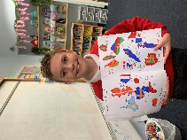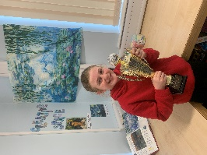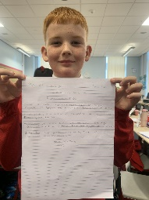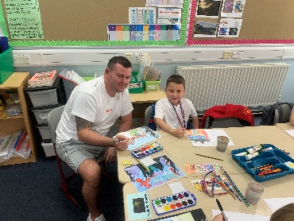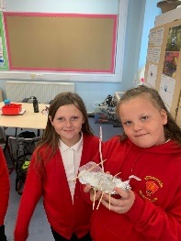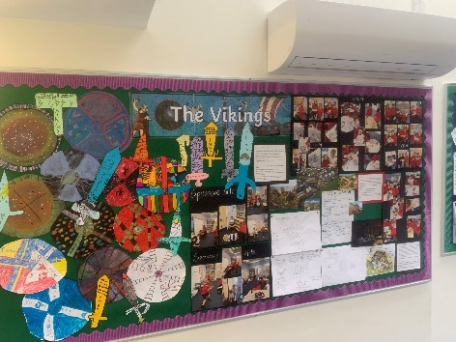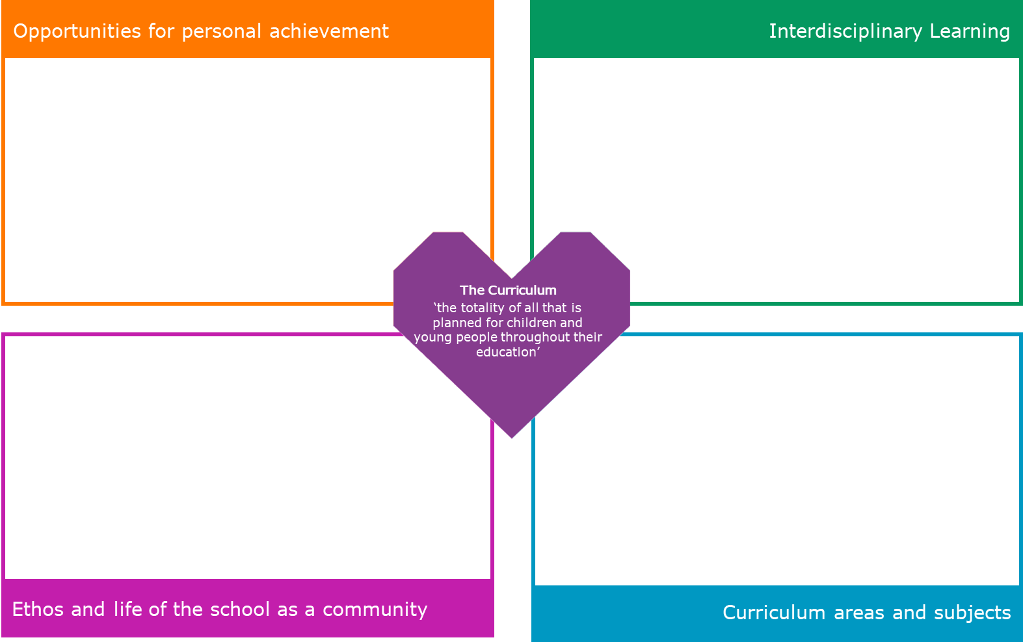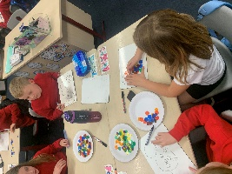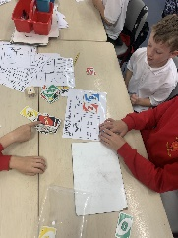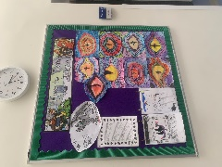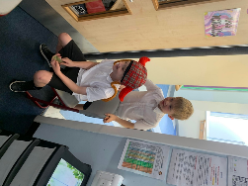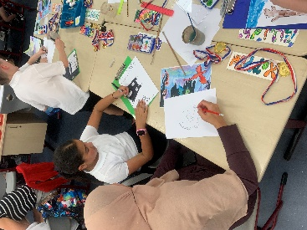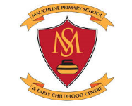

-The gallery area in the class celebrates achievements and other things that the children are proud of.

-The children get an opportunity to perform skills or tell the class about something that they are proud of/interested in.

- Children’s work is displayed on the walls.

-Feedback and successful learner stars provided in jotters.

-Head Teacher’s Award and Successful Learner Award.

-Pupil of the day.

-Star Folk of the Week and Star Group of the Week.

-**Maths**: Multiplication and division; place value; rounding; addition and subtraction word problems. Teaching methods include a mix of active maths with concrete materials, maths computer games on Sumdog, class discussions and demonstrations; and jotter textbook work for consolidation.

**Literacy:** SAC COW spelling strategies; Reading comprehension on class book HTTYD; Instructional writing; descriptive writing activities related to class novel and Halloween.

**-HWB**: PE-team games and gymnastics; PATHS; getting on with others; Food Health

**Technologies:** ICT researching using the Internet and exploring features of Powerpoint.

**Expressive Arts: Art and Design:** Get to know me art activities; Art related to HTTYD (dragon eye, designing own dragons, dragon landscape); art related to Halloween; **Music:** Strings and class singalong; **Drama:** Viking role play

**French**: Numbers, months, days of the week

Vikings

Art: Viking shields, Viking swords

STEM challenge: made longboats using tin foil, straws and bubble wrap and observed how many Jenga blocks they could take before they sank; made Viking houses using Jenga blocks and Lego.

-We had our Open Afternoon where we collaborated with parents and carers to make fabulous How to Train Your Dragon watercolour landscapes.

-We joined our new committees and are excited about playing an important role in the school.