Wb 13/5/24 Literacy | Numeracy | Other
*Active Literacy  Phoneme of the week ch  ch t tch  chief future watch  Spelling the /ch/ sound: is it ch or tch (spellzone.com)  *SpellingNessy - Log in to play and learn (nessy.com)  TRICKY WORDS- practise TW on your list. Bring your ‘Work At Home’ book to school when you think you are ready for a check-up of your words.  *WRITING This week is Mental Health Week so we will be writing a response text about what makes us feel happy, sad, worried, angry, jealous etc.  Our writing day is FRIDAY.  * READING Group Reading - Check the markers and sign when done. Remember to keep reading books in bags!  Read your Library book, any book from your own bookshelf or click on the link to login to MyOn. Sign In - myON®  MyOn passwords have all been reset as some children were having problems.  You can check the Book Level of any book using AR Bookfinder: https://www.arbookfind.co.uk/default.aspx  Don’t forget to quiz on any book you read using the link below  https://ukhosted102.renlearn.co.uk/6994660/  If you don’t have any books at home, try reading magazines, cookbooks, comics or online books.  Oxford Owls have a library of free books: https://www.oxfordowl.co.uk/  Free audiobooks for children: https://www.storynory.com | NUMERACY  Fractions  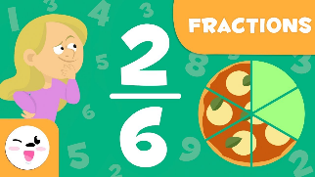  This week we will be starting work on Fractions.  ‘Fractions’ is just a fancy word for sharing/dividing.  Here are new words that you need to know.  NUMERATOR – that means the number on the top.  DENOMINATOR- that means the number on the bottom.  Scroll down to try out the Fraction of Amounts homework.  Click on the links for assigned Fraction tasks  SplashLearn  https://www.youtube.com/watch?v=lTce7f6KGE0  Revision – X8 ÷8 x5  Keep working on your X tables – use your flashcards we made in school or a pack of playing cards  Play Topmarks Bingo- Multiplication & Division.  Can you beat your own record? Could you challenge a family member to play with you?  https://www.topmarks.co.uk/  SplashLearn Sign In  Studyladder,  NUMBER of the DAY  Choose a 2 or 3 digit number and use your strategies. | 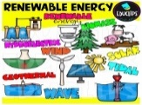 IDS ENERGY  This week we will be…  *learning about RENEWABLE energy sources and learning more about WIND power.  Mental Health Week  MHW Activity Grid  Have fun doing some things from the activity grid worksheet.  Send us some pictures!  PLPs  Remember to complete and return your term 4 PLP.

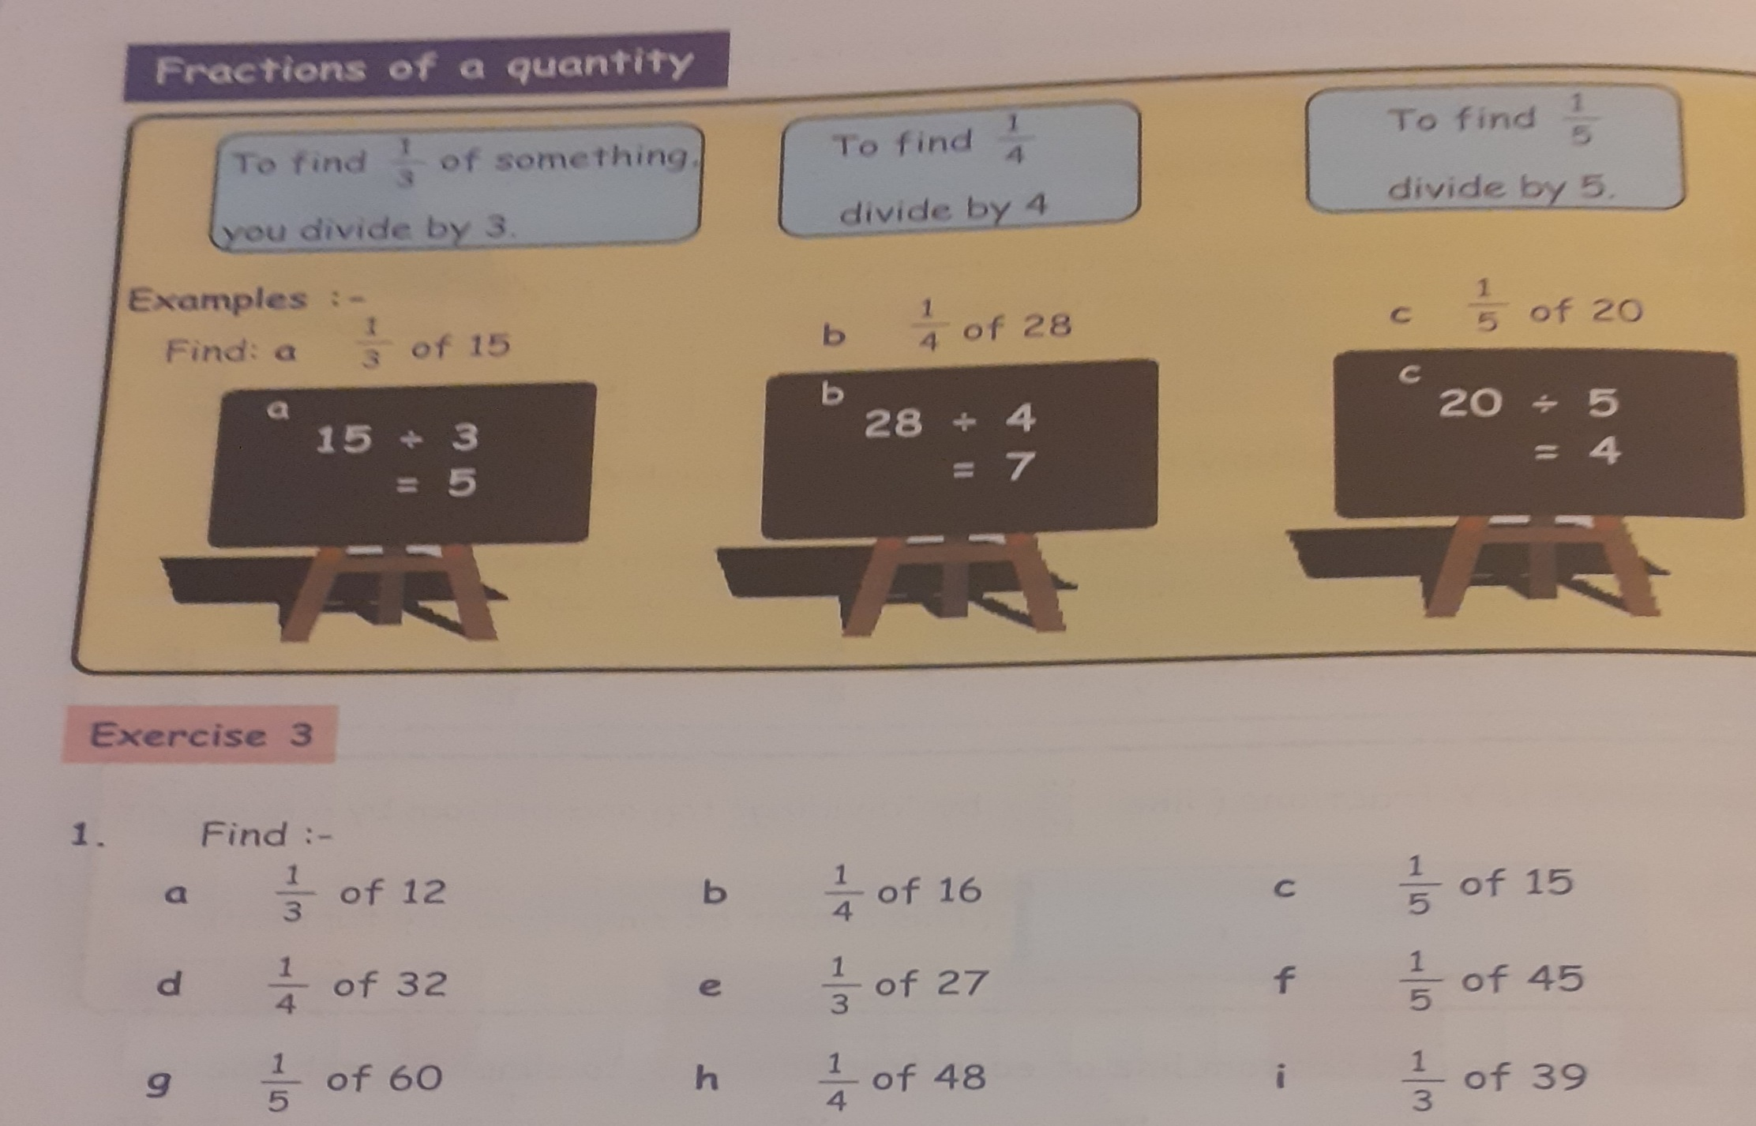 Try out a few of your own.

