Wb 6/5/24 Literacy | Numeracy | Other
*Active Literacy  Phoneme of the week ch  ch t tch  chief future watch  Spelling the /ch/ sound: is it ch or tch (spellzone.com)  *SpellingNessy - Log in to play and learn (nessy.com)  TRICKY WORDS- practise TW on your list. Bring your ‘Work At Home’ book to school when you think you are ready for a check-up of your words.  *WRITING This week is World of Work Week so we will be continuing our writing about what job we would like to do in the future.  Talk Time homework is on the next page.  Our writing day is FRIDAY.  * READING Group Reading - Check the markers and sign when done. Remember to keep reading books in bags!  Read your Library book, any book from your own bookshelf or click on the link to login to MyOn. Sign In - myON®  MyOn passwords have all been reset as some children were having problems.  You can check the Book Level of any book using AR Bookfinder: https://www.arbookfind.co.uk/default.aspx  Don’t forget to quiz on any book you read using the link below  https://ukhosted102.renlearn.co.uk/6994660/  If you don’t have any books at home, try reading magazines, cookbooks, comics or online books.  Oxford Owls have a library of free books: https://www.oxfordowl.co.uk/  Free audiobooks for children: https://www.storynory.com | NUMERACY  Fractions  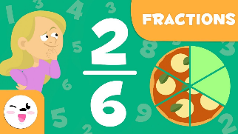  This week we will be starting work on Fractions.  ‘Fractions’ is just a fancy word for sharing/dividing.  Here are new words that you need to know.  NUMERATOR – that means the number on the top.  DENOMINATOR- that means the number on the bottom.  Scroll down to try out the Fraction of Amounts homework.  Click on the links for assigned Fraction tasks  SplashLearn  https://www.youtube.com/watch?v=lTce7f6KGE0  Revision – X8 ÷8 x5  Keep working on your X tables – use your flashcards we made in school or a pack of playing cards  Play Topmarks Bingo- Multiplication & Division.  Can you beat your own record? Could you challenge a family member to play with you?  https://www.topmarks.co.uk/  SplashLearn Sign In  Studyladder,  NUMBER of the DAY  Choose a 2 or 3 digit number and use your strategies. | 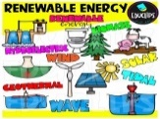 IDS ENERGY  This week we will be…  *learning about RENEWABLE energy sources and learning more about WIND power.  WORLD of WORK WEEK  This week, we will be having visitors in to speak about the jobs they do.  Interview someone at home and complete the worksheet to find out about…  *the job they do,  *why they chose it  *the pros and cons of the job.  *what skills/qualities you need to be able to do this job.  PLPs  Remember to complete and return your term 4 PLP.

Talk Time Homework
T4 Homework Task 1
This week we will be writing about…
When I grow up, I want to be…
Please talk with your child about the kinds of jobs which they are interested in doing in the future.
They should think about…
* 3 positive reasons (pros) for doing this job
* 1 or 2 negative aspects (cons) about doing this job
* what qualities or skills do they have which would make them suitable to do the job.

Have a look on the internet or in books for some job ideas and skills/qualities needed.
Take a look at the clip below for some more ideas
Jobs I Can Have When I Grow Up | Highlights Kids | Kids Videos (youtube.com)

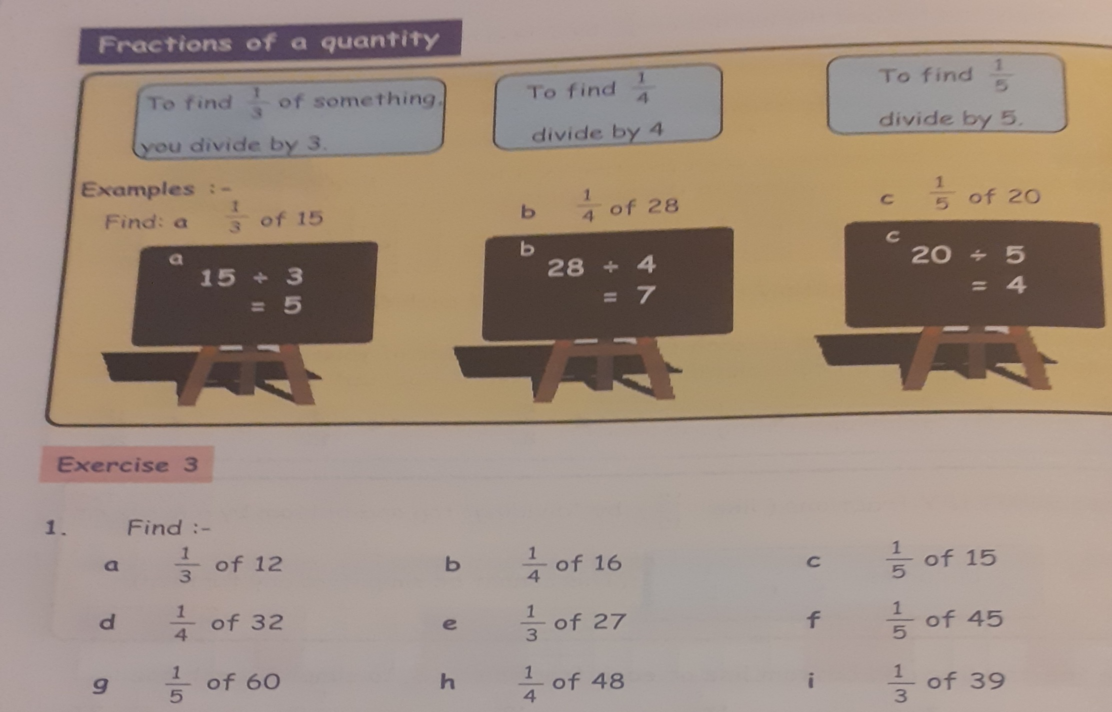
Try out a few of your own.

