Wb 19/2/24 Literacy | Numeracy | Other
*Active Literacy  Phoneme of the week k  k c ck ch qu/que kettle canine deckchair chemist antique Click on the links below for practice games qu/que Spelling games: que saying k (spellzone.com) k or ck Spelling games: ck or k (spellzone.com) CH Spelling games: Using ch to spell the /k/ sound (spellzone.com)  *Word Work Looking at Scots words which we use every day.  Reading stories in Scots e.g. The Eejits, Gruffalo in Scots etc.  Click oan the links ablow fur some hings tae dae in Scots.  HAME - Scots Hoose  Scots Language Centre  *Spelling  Nessy - Log in to play and learn (nessy.com)  TRICKY WORDS- practise TW on your list. Bring your blue ‘Work At Home’ book to school when you think you are ready for a check-up of your words.  *WRITING This week we will continue writing a RECOUNT of our visits to Burns‘ Cottage and Burns House Museum.  Our writing day is FRIDAY.  * READING Group Reading will begin again this week. Check the markers and sign when done. Remember to keep reading books in bags!  Read your Library book, any book from your own bookshelf or click on the link to login to MyOn. Sign In - myON®  MyOn passwords have all been reset as some children were having problems.  You can check the Book Level of any book using AR Bookfinder: https://www.arbookfind.co.uk/default.aspx  Don’t forget to quiz on any book you read using the link below  https://ukhosted102.renlearn.co.uk/6994660/  If you don’t have any books at home, try reading magazines, cookbooks, comics or online books.  Oxford Owls have a library of free books: https://www.oxfordowl.co.uk/  Free audiobooks for children: https://www.storynory.com | NUMERACY  Time  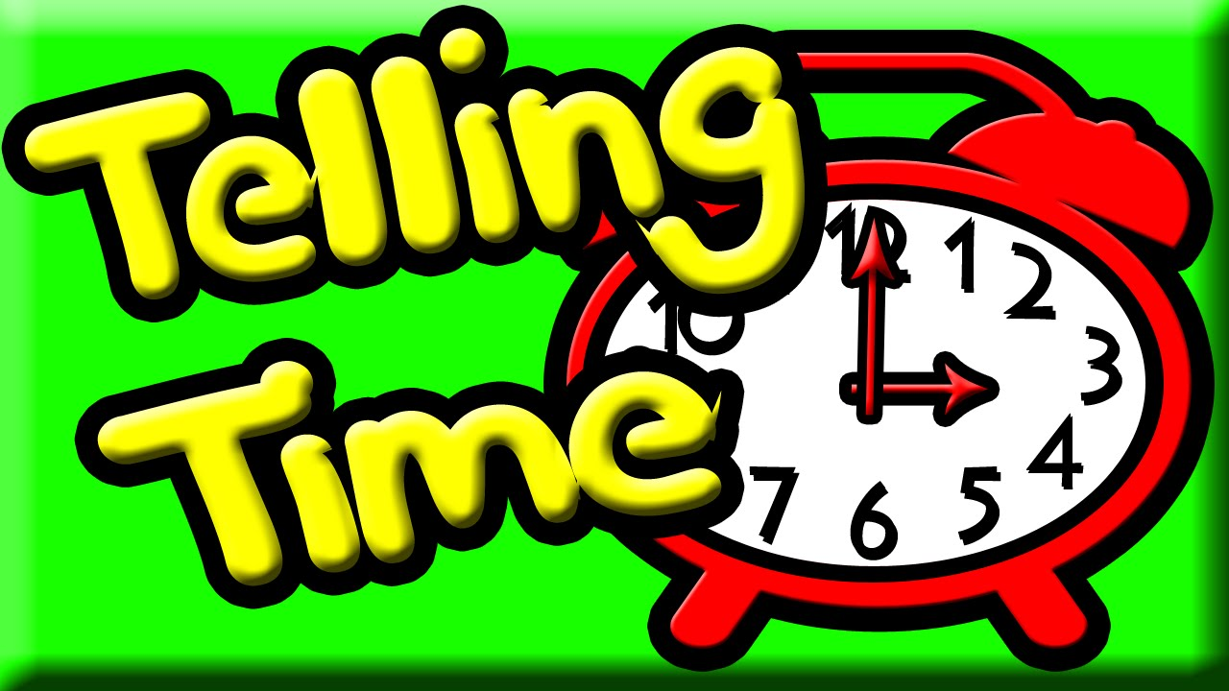This week we will be starting our work on TIME.  During this topic, we will focus on…  *telling the time – ½ past, ¼ past, ¼ to  *telling the time in 5 minute intervals  *telling the time in 1 minute intervals  *using both analogue and digital  *using am and pm  *using the 24hr clock  *time intervals  MONEY  This week we will continue to look at calculating amounts by + and x.  Use the link below for some Money games.  Money games for kids (topmarks.co.uk)  Revision – X4 ÷4 x5  Keep working on your X tables – use your flashcards we made in school or a pack of playing cards  Play Topmarks Bingo- Multiplication & Division.  Can you beat your own record? Could you challenge a family member to play with you?  https://www.topmarks.co.uk/  NUMBER of the DAY  Choose a 2 or 3 digit number and use your strategies. | Robert Burns  Assembly  *Learn your lines off by heart,  *Practise the songs  Poster Competition  Open the link for more info.  Entries by 28th March  https://www.britishscienceweek.org/plan-your-activities/poster-competition/

