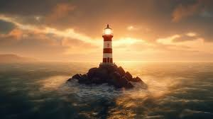

Lighthouse Home Learning Task

We are learning more about Lighthouse

Here are some of the questions we wanted to investigate. Can you help us research these questions? You can choose one question or as many as you wish.

* Where are there Lighthouses near us?
* How do they build lighthouses out at sea?
* How far does the light shine?
* How much would a lighthouse keeper have been paid?
* What type of clothes would a lighthouse keeper need to wear?

Your research results can be written into the homework jotter provided, printed out, made into a poster/chart or any other way your child would like to record their research.

Please bring in any research results by Monday 7th October when we will look at everyone’s research.

Have fun researching your child’s questions.

