Primary 2/3 Class Charter
Our class charter will make sure our class is a happy, supportive and safe place to learn!

Class Right  (Right Holders) | Mrs Bryson will…  (The Duty Bearer) | UNCRC Article | We will…  (Right Holders)
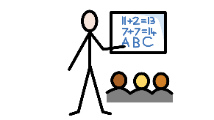  To learn every day. | Make fun, creative lessons.  Challenge us.  Help us when needed. | Article 28 – The Right to a good quality education. | Listen and work quietly.  Ask for help when we need it.  Try our best every day.
To play and relax in different activities. | Give us opportunities to play in school and find time to relax.  Make time for Fit 15. | 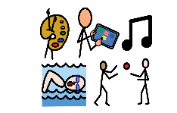  Article 31 – The Right to play and rest | Take part in MISP  Be prepared for our P.E. time.  Enjoy our Fit 15, trying to get our mile!
To be listened to. | Allow time for listening to her class and allowing opportunities for personalisation, planning together and choice | Article 12 – The Right to give your opinion and for adults to listen and take it seriously. | Listen to what others have to say.  Put my hand up to speak.
To choose who we play with. | Will encourage you to pick who you learn and play with. | Article 15- The right to choose your own friends and join or set up groups as long it isn’t harmful to others. | Have kind hands.  Show that you are a good friend.  Good friends play, share and help each other.

