W.b 19.2.24
Literacy | Numeracy
This week we are learning the “a_e” sound.  Here is a link to help you with this.  https://www.youtube.com/watch?v=tp_iuG2uHY4  The word lists are below on the following page.  Practice reading these words.  Break the words into the sounds and then blend together.  Practice writing your words in a sentence.  Read through the phoneme story and highlight the “a-e” words.  Our tricky words this week are: make made take gave  This week, you can use rainbow writing for your spelling word. Practice writing them in a sentence | We are learning about multiplication as repeated addition. We are focusing on the 2 times table.  Eg. 4x2 = 4 groups of two  2 + 2 + 2 + 2 = 8  So 4x2 = 8  Can you practice the following multiplications using the same method as above and laying it out like I have in your jotter.  3 x 2 =  5 x 2 =  6 x 2 =  2 x 2 =  7 x 2 =  8 x 2 =  9 x 2 =
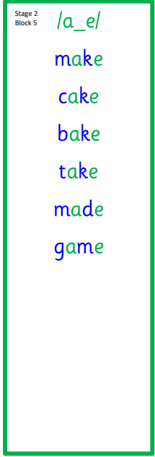
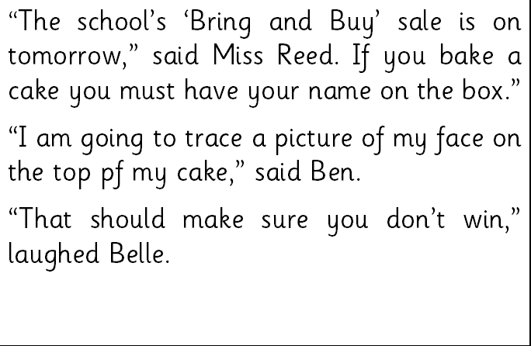
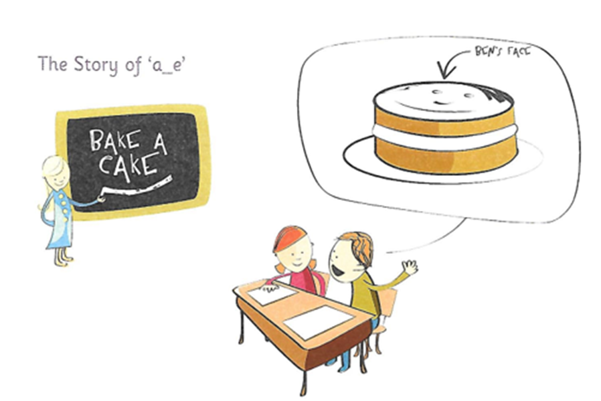
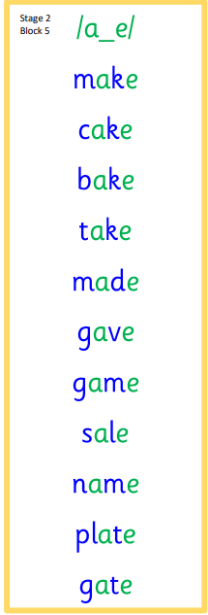

Rainbow writing:
well well well well
tell tell tell tell
will will will will
call call call call
small small small small

