W.b 29.1.24
Literacy | Numeracy
This week we are learning the “i_e” sound.  Here is a link to help you with this.  https://www.youtube.com/watch?v=JrGmIGB__54  The word lists are below on the following page.  Practice reading these words.  Break the words into the sounds and then blend together.  Five spells five  Practice writing your words in a sentence.  Read through the phoneme story and highlight the “i-e” words.  Our tricky word this week is: time  This week, you can use rainbow writing for your spelling word. | We are learnig about measuring using non-standard units eg. Measuring using cubes, paper clips, pencils etc.  Can you find 5 items around the house and measure using non-standard units.  Record them in your homework jotter.  I have also set you a sumdog challenge so login to your sumdog and it will be called “homework 29.1.24”
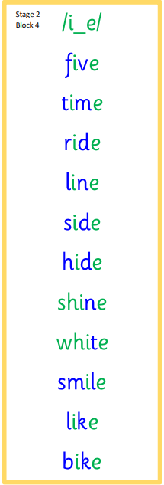
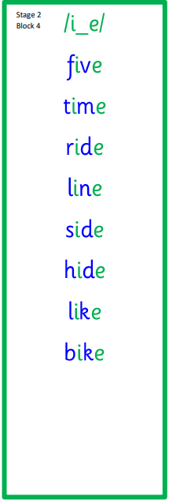
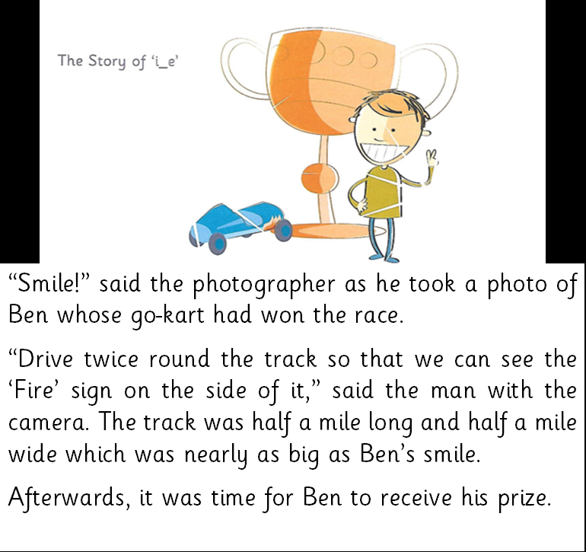
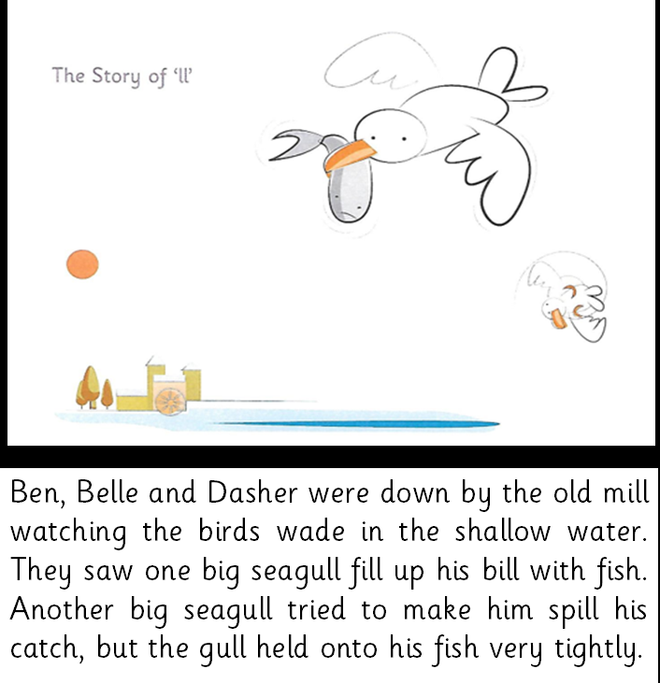

Rainbow writing:
well well well well
tell tell tell tell
will will will will
call call call call
small small small small

