Week beginning: 11.11.24 Primary 1
Literacy | STEM | HWB
Phonics  We have been learning to recognise and read using phonemes. Phonemes are the sounds that make up words. This week is our phonemes are h and r.  Watch the videos of Geraldine the Giraffe. Can you find some objects at home with our phonemes this week?  You will also get a copy of h and r for your phoneme jotter at home. Spend some time practising letter formation.  Hh  https://www.youtube.com/watch?v=Oiu_YmW_Efk  Rr  https://www.youtube.com/watch?v=R_NgOtt0Htw  Reading.  Practise your reading words.  Spelling  Our new spelling words for this week are  - am  - me  - my  Practise some spelling activities with these words that are on the blog for this week. | Over the next few weeks we will be learning about water as part STEM.  At home, make a boat that floats and bring it into school by 18/11/24.  The boat should be sturdy enough to be able to float whilst holding at least 5 plastic counting bears.  Your boat must:  - be able to fit in a washing up basin  - have a sail  - hold at least 5 plastic counting bears.  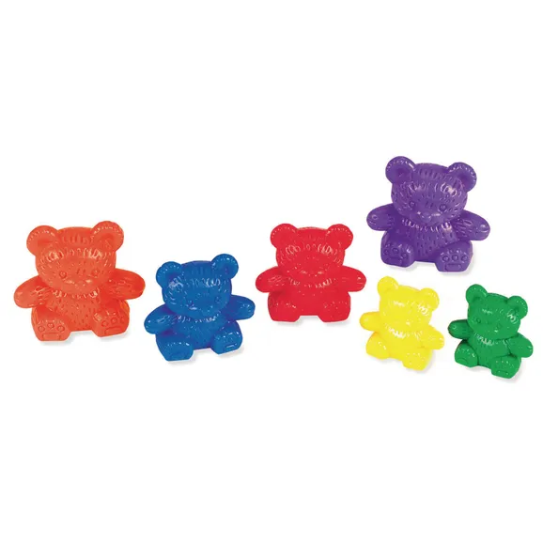  Materials you may wish to use:  - Plastic container (e.g. a butter tub).  - Plasticine  - Foil  - Lollipop sticks  - Sellotape  These are some ideas. Feel free to use other materials you may have. | Anti-Bullying week  It is Anti-bullying week this week.  We are going to be learning about bullying and what it means to be unique. At home, please discuss what it means to be unique and discuss some ways which we can be a good friend.  In PAThS this week, we will be learning about friendship. We will learn that friends share, play and help each other.  