Week beginning: 28.10.24 Primary 1
This is an update of some of our learning in Primary 1 so far.
Literacy | Numeracy | HWB
Phonics  We have been learning to recognise and read using phonemes. Phonemes are the sounds that make up words. This week is our consolidation week. We will be practising all of the phonemes covered so far: s, a, t, i, p, and n.  Please try the game called ‘SATPIN Sound Sort’. I have attached the file on the homework page of the P1 blog. Alternatively, talk about items at home or in the environment and discuss which phonemes they begin with.  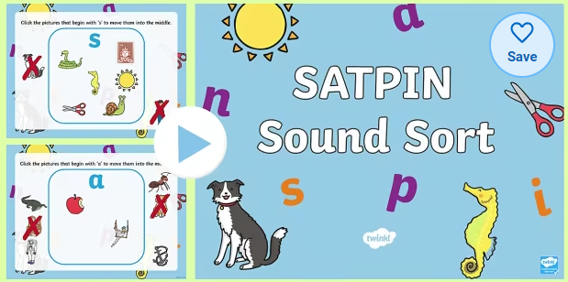  Reading.  Practise your reading words.  Spelling  We have been learning to write the words: ‘I’, ‘a’, ‘at’, ‘the’, ‘it, and ‘in’.  Try the activities below to help you learn your words:  - Three times – write out your words three times.  - Rainbow writing – write your words. Copy over the top in a different coloured pencil. Repeat 3 or 4 times using a different colour each time.  - Air writing – write your words in the air with your finger. Ask someone to read the words as you write. Or ask someone to air write the letters you tell them to spell your word. | Play the game called ‘In 30 Seconds’.  The adult times 30 seconds on their watch and the child explores what they can do in that time, for example, how many times they can hop around the carpet. They record what they do on paper so they can bring it back to school to show the other children and adults. | Clean Green Rocket Design  The ‘Shoot to Saturn’ programme aims to encourage children and young people to make their journeys to and from school active ones.  Homework:  Design a space rocket to promote the Shoot to Saturn Programme (paper will be provided).  There is more information about Shoot to Saturn on the Safer Schools app.  

