Week beginning: 07.10.24 Primary 1
This is an update of some of our learning in Primary 1 so far.
Literacy | Numeracy | Autumn
Phonics  We have started learning our phonemes. This week we are learning the phonemes ‘i’ and ‘p’.  Can you find any items at home that have the sounds ‘i’ or ‘p’ at the beginning, middle or the end of the word?  Watch the videos below and practise writing the letters. Remember to start and finish at the correct places.  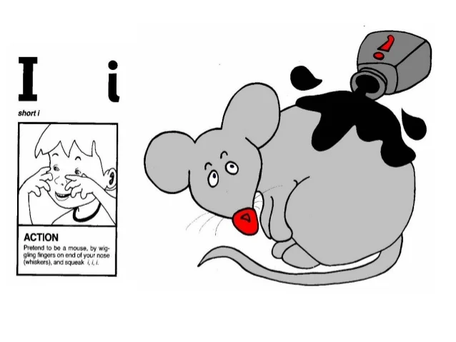  https://www.youtube.com/watch?v=d5xnlvH_ICo  https://www.youtube.com/watch?v=YpdUGqY08gY  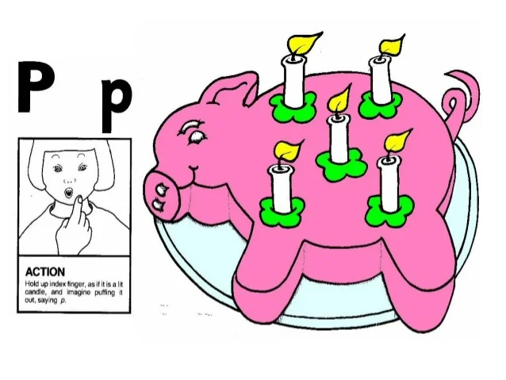  https://www.youtube.com/watch?v=yG6LPfg-rDE  https://www.youtube.com/watch?v=lrw6d5FI-Qs  Reading.  Practise your reading words.  Spelling  We have been learning to write the words: ‘I’, ‘a’ and ‘at’.  Try the activities below to help you learn your words:  - Three times – write out your words three times.  - Rainbow writing – write your words. Copy over the top in a different coloured pencil. Repeat 3 or 4 times using a different colour each time.  - Air writing – write your words in the air with your finger. Ask someone to read the words as you write. Or ask someone to air write the letters you tell them to spell your word. | We have been building our confidence with counting items. We have been learning that when objects are moved around, the quantity stays the same.  We have also been practising our number formation. Spend some time writing numbers. This could be with pencils, pens, crayons, paint or chalk.  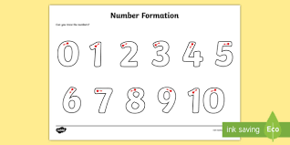  We will also be ordering numbers. Try the gingerbread man game on Topmarks:  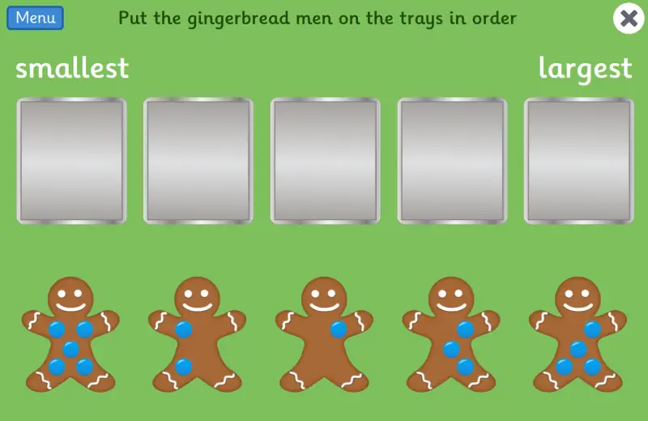  https://www.topmarks.co.uk/learning-to-count/gingerbread-man-game  https://www.topmarks.co.uk/maths-games/5-7-years/counting | We have been learning about Autumn.  Collect some autumn items from the garden or from an autumn walk and try to create your own autumn artwork. Talk about your artwork and see if you can spot any patterns or shapes.  You could post your artwork on Learning Journals so we can talk about it in class.  Here are some examples:  