Week beginning: 30.09.24 Primary 1
This is an update of some of our learning in Primary 1 so far.
Literacy | Numeracy | Autumn
Phonics  We have started learning our phonemes. Please practise writing the letters. Use the links below to help you. You will take home a Phonics jotter this week which you can practise in.  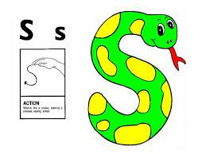  https://www.youtube.com/watch?v=IxysX-vbb9s&list=PLv80XE_mA4uy5WO-mMcUQ2vX6AdVpIPEk&index=19  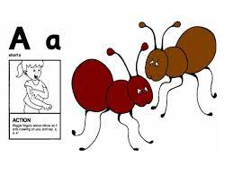  https://www.youtube.com/watch?v=gg8-Zg99FbI&list=PLv80XE_mA4uy5WO-mMcUQ2vX6AdVpIPEk  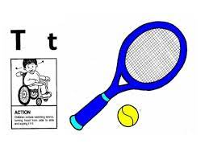  https://www.youtube.com/watch?v=cFPnvswgT8A&list=PLv80XE_mA4uy5WO-mMcUQ2vX6AdVpIPEk&index=20  Reading.  Practise your reading words. | We have been building our confidence with counting items. We have been learning that when objects are moved around, the quantity stays the same.  Go on a number hunt at home or outside. Numbers are everywhere around us. Where can you find numbers? For example, can you see numbers on clocks, road signs, buses, car registration plates or items at home. Can you find numbers written as words? Talk about what you see.  There are some games on Topmarks to consolidate counting. You can also practise counting objects at home.  https://www.topmarks.co.uk/maths-games/5-7-years/counting | We have been learning about Autumn.  Go out for a walk and use your senses to talk about the signs of autumn that you can see, feel and hear. You may wish to look at the autumn checklist to help you. Please bring in a small amount of autumn materials for our tuff tray if you find any when out your walk, for example, pinecones, acorns, different coloured leaves or conkers.  