Primary 1 Learning Update 29.4.24
Literacy | Numeracy | HWB
Phonics  This week we will be learning the phonemes:  qu and ou  Can you think of any words that have the qu or ou phonemes?  e.g queen, quack, mouth, cloud, shout,  Practise writing them.  Reading  Your child should have a new reading book. Please spend some time reading and talking about the book.  Writing  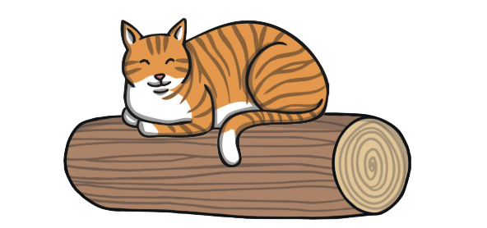  Write 2 or 3 sentences about the picture. | Numeracy  This week we will be learning about fractions (halving) and making a fair share.  Game: Play ‘George’s Busy Day’ and share the bones equally between the dogs.  https://pbskids.org/curiousgeorge/busyday/dogs/  Try practising your number formation:  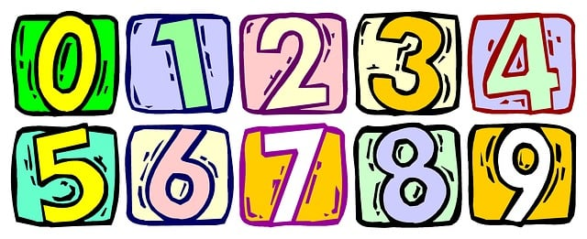  Try writing out the number words:  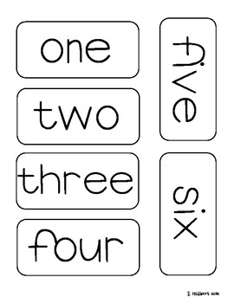 | In PATHS we have been learning about sharing and caring. We have shared jokes and stories with each other. Sharing helps everyone to feel happy.  Spend some time together and share stories, play a board game or share compliments with each other.

