Primary 1 Learning Update 25.03.24
Literacy | Numeracy | Health and Wellbeing
Phonics  This week we will be learning the phonemes: ch and s. Please practise writing the letters by starting and finishing at the correct places. You could use different coloured pencils, paints or chalk outside. If you are reading a book at home try spotting some words with the ch or sh phonemes.  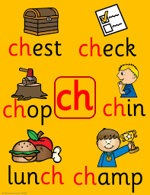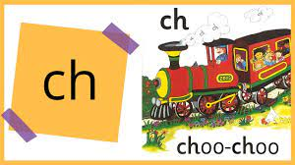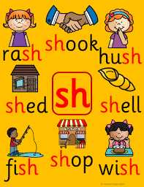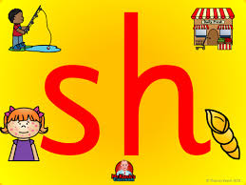  Reading  We will not be giving out new reading books due to the shorter week and easter activities. Practise reading and spelling the pink words.  Writing  Can you write some sentences on your own to describe the Easter egg? | Numeracy  We have started learning about time.  Create a simple daily routine chart with pictures or drawings representing different activities throughout the day (e.g., wake up, breakfast, playtime, bed time).  Example:  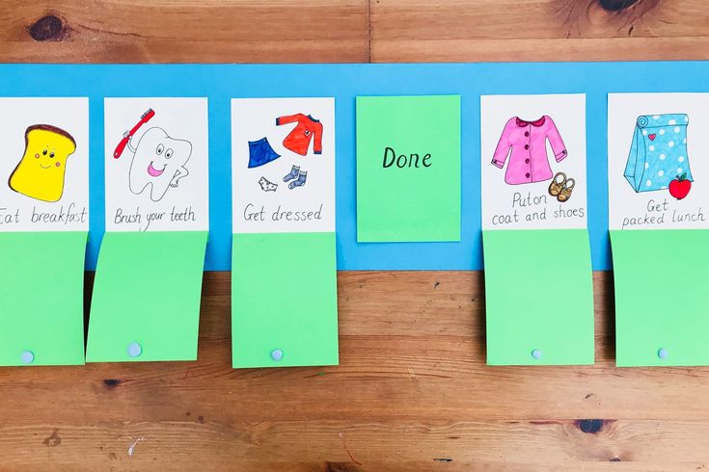  Spend some time outdoors and observe the changes in the sky throughout the day. What do you notice about the sky in the morning, at noon and at night?  This activity will introduce the concept of how time passes during the day. | 