Primary 1 Learning Update 5.02.24
Literacy | Numeracy | Health & Wellbeing
Phonics  This week we will be consolidating the phonemes  ai, j, oa, ie, ee and or.  Spelling  We will be learning to spell the words:  - Was  - Went  - You  Reading  As it is a shorter week this week, we will not give out any new reading books. Have a look at home for any books that have not been returned and please bring them back to school. Spend some time reading some books of your choice at home. If you don’t have any books at home let us know and a book can be chosen from the class library.  Practise reading your pink reading words and if you can read them all try to make sentences with your words and have a go at spelling them. If you have lost your reading words, please let us know. | We have been learning about 2D and 3D shape. Have a go at making a robot out of junk materials you have in your home. If possible, please bring it in to school at by the 15th February so we can display your robot.  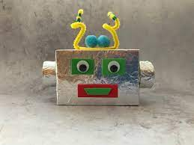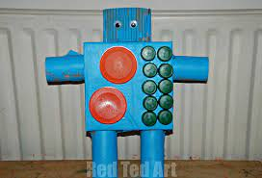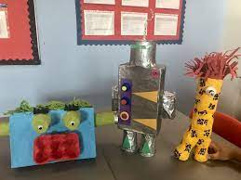  In class we will continue to learn our number stories.  The Number stories are all the calculations that make a quantity, e.g. the number story of 2 is: 2+0, 0+2 and 1+1Try the game called ‘Ways to Make’ on Topmarks. Put the teddy bears into the houses to complete the addition calculations.  https://www.topmarks.co.uk/Flash.aspx?f=WaystoMake | This week is Children’s mental health week. We will be doing some activities in class to learn about mental health.  We will be reading the book ‘Speak up!’ by Nathan Bryon and doing some activities in class. If you’d like to hear the story, click on the link.  https://www.youtube.com/watch?v=rp6A7FdC3Cc  Design your Caddy task – photo on the blog.

