Week beginning: 15.1.24 Primary 1
This is an update of some of our learning in Primary 1 this week.
Literacy | Numeracy | Health and Wellbeing
Phonics  We have been learning to recognise and read using phonemes. Phonemes are the sounds that make up words.  This week we will be learning about the phonemes ai and j.  Spelling  You can practise writing these words at home or make them out of playdoh: be but you  Reading  Continue to practise the pink reading words. You can try to arrange the words into sentences. Your child will also bring home a reading book at on either Monday or Tuesday. Try reading this at home every night and practise the words that your child is finding difficult. | We will be learning all about 3D shapes.  Try going on a shape hunt in your house or garden. Can you find any spheres, cubes, cuboids, cylinders, cones or triangular prisms?  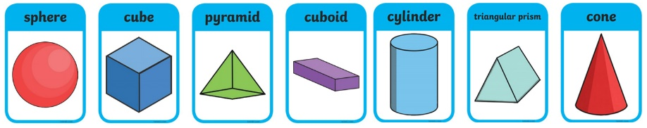 | We have been learning about our senses.  Talk about the 5 senses – touch, sight, smell, hear and taste.  Have a try at smelling some different things at home and talk about them.

