Week beginning: 11.12.23 Primary 1
This is an update of some of our learning in Primary 1 this week.
Literacy | Numeracy | Health and Wellbeing
Phonics  We have been learning to recognise and read using phonemes. Phonemes are the sounds that make up words. Click on the link for a short video all about the sound we will be learning about this week.  Ff  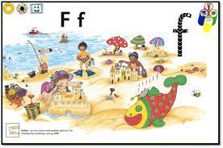  https://www.youtube.com/watch?v=xb2zrZX3-9M  Reading  Continue to practise the pink reading words. Your child should also have a log in for teach your monster to read. You can play the game online or download the app on to a device at home. We will also have a chance to play this reading game at school.  Spelling  This week we will be learning the spelling words ‘go’, ‘got’ and ‘get’. Try writing these words down at home or you may want to make them out of playdoh or stones on the ground. | Activity  This week we will be doing some numeracy activities based on the story ‘Mogs Christmas.’  Read the story at home if you have it, if not you can listen to it on the Youtube link below:  https://www.youtube.com/watch?v=Fn3a0a6AAaI  Estimate  Can you guess how many baubles are on Mog’s Christmas tree? Provide opportunities at home to estimate a variety of Christmas objects e.g small baubles in a jar, presents under a tree, number of cards in a pile. Estimate and check how close their answer is.  Symmetry  One of our activities is to create a symmetrical picture. Try doing this at home with paint, crayons or do some outdoor artwork with natural materials.  You can also play this symmetry game from Topmarks.  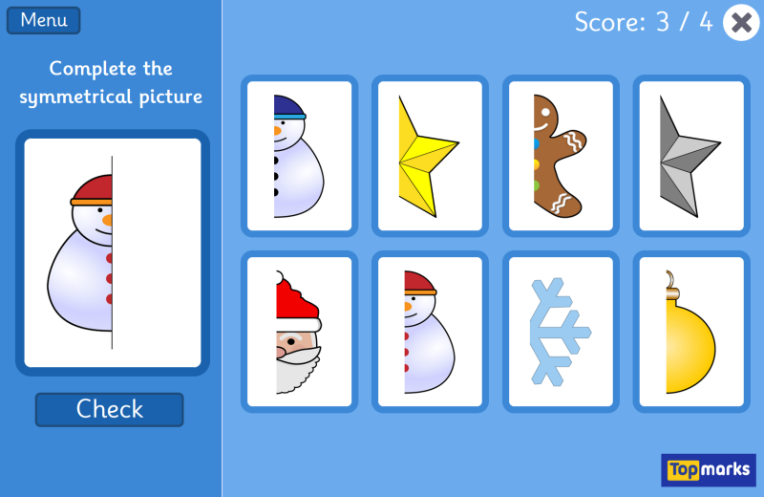https://www.topmarks.co.uk/symmetry/symmetry-matching | This week we have our nativity dress rehearsal on Tuesday and the performances on Thursday and Friday. The children have all worked so hard. Spend some time talking about how you feel about the nativity. Maybe you are feeling exciting or nervous about it.  We will be writing about our experience in the nativity this week so it will be helpful to talk about it at home.  