Week beginning: 4.12.23 Primary 1
This is an update of some of our learning in Primary 1 this week.
Literacy | Numeracy | Health and Wellbeing
Phonics  We have been learning to recognise and read using phonemes. Phonemes are the sounds that make up words. Click on the links for a short video all about the sounds we will be learning about this week.  Uu  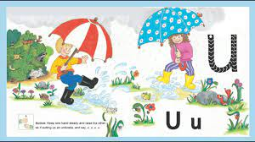  https://www.youtube.com/watch?v=mHOokD5IYOg  Ll  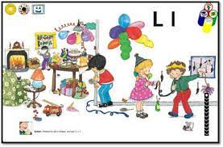  https://www.youtube.com/watch?v=3kfvvK7GHSw  Reading  Continue to practise the yellow reading words. By the end of this week you should have 3 more reading words in the word bag no, but, a. please spend some time practising these words. Try reading a book of your choice at home.  Spelling  This week we will be learning the spelling words ‘can’, ‘we’ and ‘into’. Try writing these words down at home or you may want to make them out of playdoh or stones on the ground. | We have been building our confidence with counting items, matching quantities to numerals and ordering numbers. We have been learning about combining two quantities and working out how many there are all together. We have also been learning to add on one by counting from any given number.  Click on the link to go to the topmarks game. Go to up to 10 and 1 more.  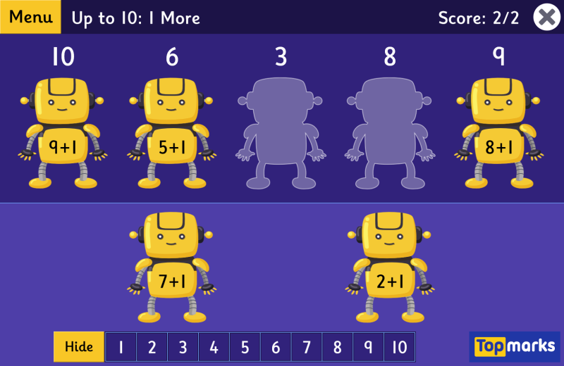https://www.topmarks.co.uk/maths-games/robot-more-or-less  Activity  For the next 2 weeks we will be doing some numeracy activities based on the story ‘Mogs Christmas.’  One of our activities is to create a symmetrical picture. Try doing this at home with paint, crayons or some outdoor artwork with natural materials.  You can also play this symmetry game from Topmarks.  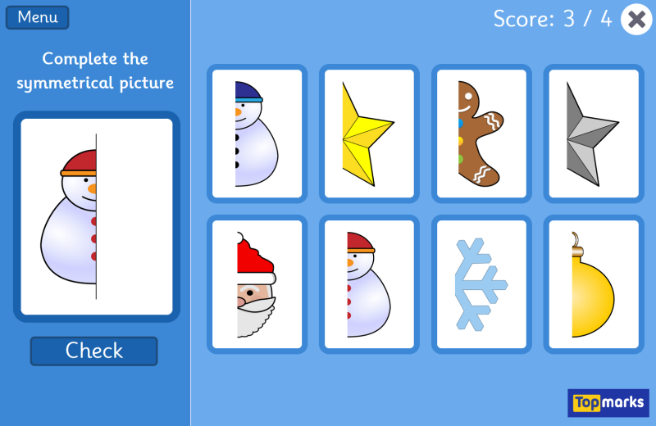  https://www.topmarks.co.uk/symmetry/symmetry-matching | If you have not had the chance to do so please check your Learning Journals this week for your child’s targets. Please talk with your child about their targets and add a Health and Wellbeing target by commenting on your profile.  At our PAThs time we will be learning all about the feeling scared and afraid. Have a chat at home about what makes you feel afraid.  