Week beginning: 20.11.23 Primary 1
This is an update of some of our learning in Primary 1 so far.
Literacy | Numeracy | Health and Wellbeing
Phonics  We have been learning to recognise and read using phonemes. Phonemes are the sounds that make up words. Click on the links for a short video all about the sounds.  This week will be a consolidation week. We will be consolidating the phonemes c,k,e,h,r,m,d. Your child should have a copy of these phonemes in their school bag. Cut these out and use them as flashcards – you can also use the SATPIN phoneme cards to make CVC words and try to read them.  Dd – can you see any items in the picture that have the ‘d’ phoneme?  Can you find any items at home that have the ‘d’ phoneme at the beginning, middle, or the end of the word?  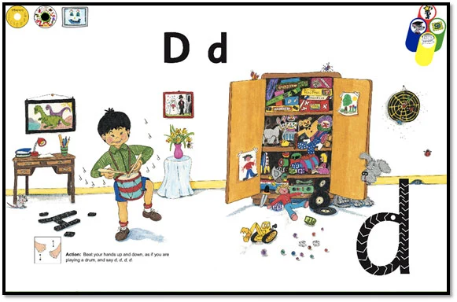  https://www.youtube.com/watch?v=kxHGPWFmMSA  https://www.youtube.com/watch?v=g3aadNOIjvQ  Reading.  Please continue to practise your reading words and spend some time reading your new book at home. Please return this by Friday. | We have been building our confidence with counting items, matching quantities to numerals and ordering numbers.  We have been learning about combining two quantities and working out how many there are all together.  Activity  Check your child’s school bag for a worksheet focusing on 1 more than, number after and +1. This does not need to be returned to school. | Please check your Learning Journals this week for your child’s PLP targets. Please talk with your child about their targets and spend some time working towards your health and wellbeing target at home.  