Week beginning: 06.10.25 Primary 1
This is an update of some of our learning in Primary 1 so far.
Literacy | Numeracy | Autumn
Phonics  We have started learning our phonemes. This week we are learning the phonemes ‘i’, ‘p’ and ‘n’.  Can you find any items at home that have the sounds ‘i’, ‘p’ or ‘n’ at the beginning, middle or the end of the word?  Watch the videos below and practise writing the letters. Remember to start and finish at the correct places.  I i  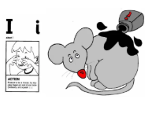  https://www.youtube.com/watch?v=d5xnlvH_ICo  https://www.youtube.com/watch?v=YpdUGqY08gY  P p  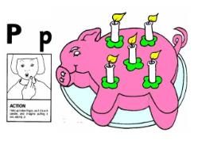  https://www.youtube.com/watch?v=yG6LPfg-rDE  https://www.youtube.com/watch?v=lrw6d5FI-Qs  N n  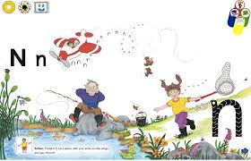  https://www.youtube.com/watch?v=qP7rd02SQ4o&list=RDqP7rd02SQ4o&start_radio=1  https://www.youtube.com/watch?v=sIBUOfV7Y2U  Spelling words  The, I, at, it , in, a  Reading.  Practise your reading words. | We have been building our confidence with counting items and arranging numbers and quantities in order. We have been learning that when objects are moved around, the quantity stays the same.  There are some games on Topmarks to consolidate counting. You can also practise counting objects at home.  https://www.topmarks.co.uk/maths-games/5-7-years/counting  This week, you will take home the number that shows your age. Can you decorate your number? For example, you can paint it or stick arts and crafts to it (stickers, pompoms, fuzzy material etc.) Bring your decorated number back to school so that we can put it on the Numeracy wall.  Go on a number hunt at home or outside. Numbers are everywhere around us. Where can you find numbers? For example, can you see numbers on clocks, road signs, buses, car registration plates or items at home. Can you find numbers written as words? Talk about what you see. | We are going to be learning about Autumn.  Go out for a walk and use your senses to talk about the signs of autumn that you can see, feel and hear. You may wish to look at the autumn checklist to help you. Please bring in a small amount of autumn materials for our tuff tray if you find any when out your walk, for example, pinecones, acorns, different coloured leaves or conkers.  