Week beginning: 29.09.25 Primary 1
This is an update of some of our learning in Primary 1 so far.
Literacy | Numeracy | Health and Wellbeing
Phonics  We have started learning our phonemes. Click on the links for a short video all about the sounds we will be learning.  s  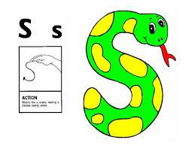  https://www.youtube.com/watch?v=bD7HXCl5v2c  a  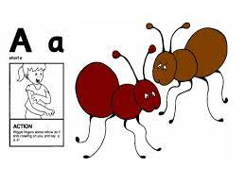  https://www.youtube.com/watch?v=gnC02Hr2oSk  t  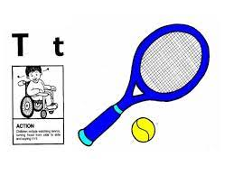  https://www.youtube.com/watch?v=_8VIbSUOe3Q  Spelling words  the  I  at  Reading.  Practise your reading words. | We have been building our confidence with counting items and arranging numbers and quantities in order. We have been learning that when objects are moved around, the quantity stays the same.  There are some games on Topmarks to consolidate counting. You can also practise counting objects at home.  https://www.topmarks.co.uk/maths-games/5-7-years/counting  This week, you will take home the number that shows your age. Can you decorate your number? For example, you can paint it or stick arts and crafts to it (stickers, pompoms, fuzzy material etc.) Bring your decorated number back to school so that we can put it on the Numeracy wall.  You can also practise writing your numbers. Remember to start and finish at the correct places.  You can write your numbers on a piece of paper in different colours (Rainbow Writing) or you can use the website below.  https://www.doorwayonline.org.uk/literacy/letter-and-number-formation/ | We have been learning about what it means to be happy. Have a chat at home about what it means to be happy.  Do some activities at home that make you feel happy.  