Week beginning: 09.12.24 Primary 1
Literacy | Numeracy | Spelling Words
Phonics  We have been learning to recognise and read using phonemes. Phonemes are the sounds that make up words. Spend some time practising letter formation.  Our phoneme this week is: ‘u’  Can you find any items at home that have the phoneme ‘u’.  Watch the videos below:  Uu  https://www.youtube.com/watch?v=RRdzsvPUMh0  https://www.youtube.com/watch?v=kmmewEew6lM  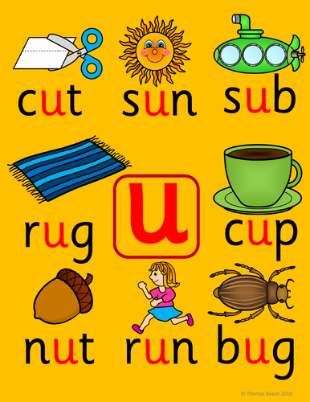  Reading.  Practise your reading words. Spend some time reading your reading book. Please bring the book to school every day as we use the books in school as well as home.  Spelling  Our spelling words for this week are:  go, got, get | We will be learning about 2D and 3D shapes.  Talk about 3D shapes you can see in real life for example, when you are out for a walk or out shopping. Look around for some everyday items that are these shapes:  Cube, cuboid, cone, sphere, cylinder.  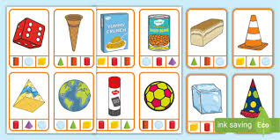  We have also been learning about patterns. Here is a Christmas patterns game.  https://www.topmarks.co.uk/ordering-and-sequencing/christmas-patterns | We are going to be learning to write a sentence independently.  Below is a list of all the spelling words we have been practising so far. Please spend some time at home practising them.  You could write the words in different colours, make the words with playdough or paint the words.  There are more ideas on the homework tab on the blog page.  a, as, at, the, I, at, is, an, and, am, me, my, did, as, he, can, we, into, go, got, get

