Week beginning: 02.12.24 Primary 1
Literacy | Numeracy | H&WB
Phonics  We have been learning to recognise and read using phonemes. Phonemes are the sounds that make up words. Spend some time practising letter formation.  Our phonemes this week are: ‘g’ and ‘o’  Can you find any items at home that have the phonemes ‘g’ or ‘o’?  Watch the vidoes below:  Gg  https://www.youtube.com/watch?v=rwFKK-XcViw  https://www.youtube.com/watch?v=f9ew08BXrZA  Oo  https://www.youtube.com/watch?v=_t8uSTn4ruU  https://www.youtube.com/watch?v=UGoHruVS-bY  Reading.  Practise your reading words. Spend some time reading your reading book. Please bring the book to school every day as we use the books in school as well as home.  Spelling  Our spelling words for this week are:  can  we  into | We will be learning about 2D and 3D shapes.  Spend some time looking around your house for some everyday items that are these shapes:  Cube, cuboid, cone, sphere, cylinder.  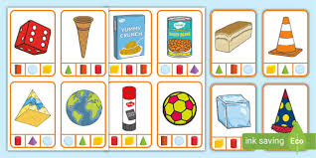 | Design your caddy:  The ECO committee are running a competition for pupils to design our school caddy.  Please put your name and class on the template and hand it in by Friday 13th December.  You will get the template home this week.

