Primary 1 Learning Update 13.5.24
Literacy | Numeracy | Writing
Phonics  This week we will be learning the phonemes er and ar.  Listen and sing along to the er and ar songs.  er Can you find any items at home that have the er phoneme? For example, mixer, sister or dinner.  ar Can you think of any words that have the ar phoneme? For example, car, park or star.  Spelling  Our spelling words this week will be: out, new and now. Please practise writing the words at home.  Here are two activities that you might want to try:  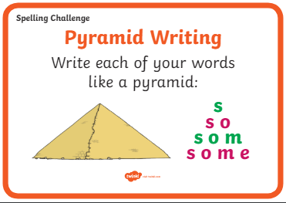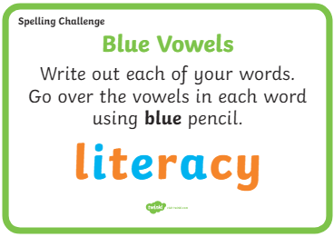  Reading  Your child should have a new reading book. Please spend some time reading and talking about the book. | Numeracy  This week we will be learning about money.  Try identifying coins at home and talk about their values. You could set up a shop and make price tags for toys. Take turns in role play being the shop keeper and the customer. Talk about and practise giving the customer change.  Suggested activities:  https://www.topmarks.co.uk/money/toy-shop-money  Play the toy shop money game. Click on ‘mixed coins’, ‘up to 20p’.  Play the ‘Coins Game’  https://www.topmarks.co.uk/money/coins-game  Practise your number formation:  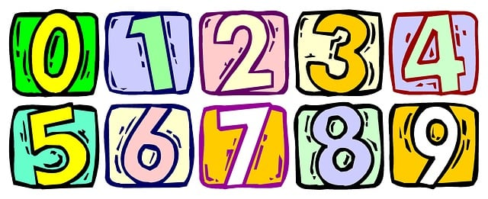  Try writing out the numbers as tally marks. | This week we will be writing a story about the Three Little Pigs. Please talk to your grown-ups about another material the little pigs could use to build their house. Use your imagination – it can be any material that you can think of. Will the Big Bad Wolf be able to huff and puff and blow the house down?  Try and design, draw or build your house using the material you will write about in your story.  