Primary 1 Learning Update 23.4.24
Literacy | Numeracy | IDL
Phonics  This week we will be consolidating the phonemes:  Yy, Xx, ch, sh, th.  How many words can you think of that have these phonemes at the beginning, middle or end of the word?  e.g yes, six, chop, brush, thumb  Practise writing them.  Reading  Your child should have a new reading book. Please spend some time reading and talking about the book.  Writing  Can you write some sentences on your own to describe the cherry blossom tree?  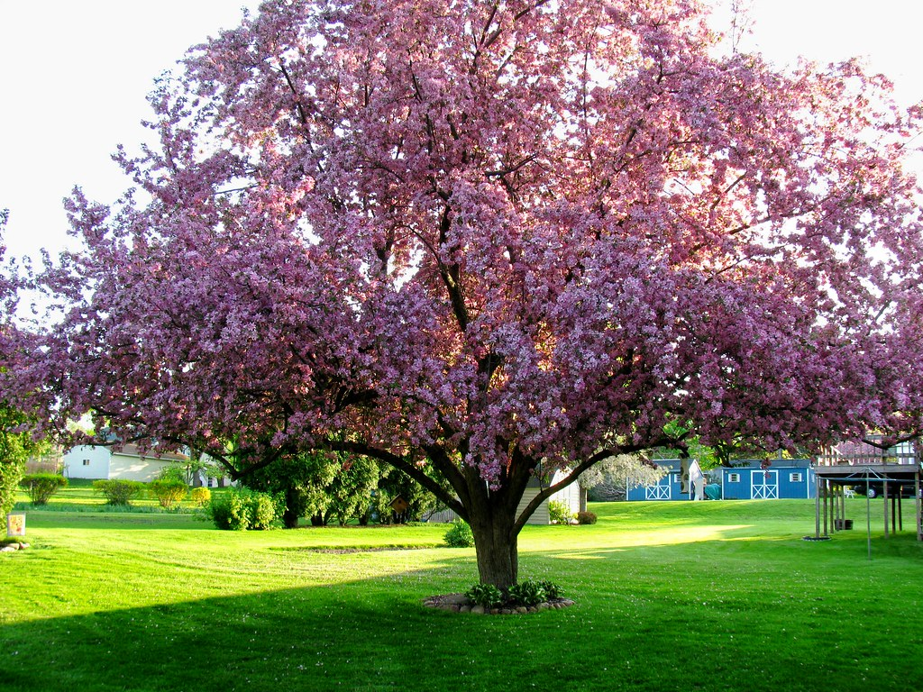 | Numeracy  This week we will be:  Adding  Subtracting  Ordering numbers backwords and forwards  Writing the number words  (within 5, 10 or 20)  Game:  https://tangmath.com/numtanga  Match the pairs that could be numerals, words and quantities  Try practising your number formation:  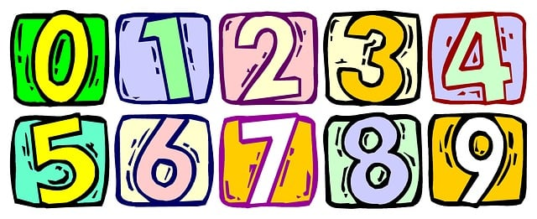  Try writing out the number words:  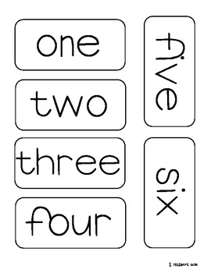 | We have now started to learn all about spring. Have a look in your garden or go out a walk and see if you can spot any signs of spring.  You may want to write a sentence describing some of the things you can see. Think about your senses on your walk.  