Primary 1 Learning Update 26.02.24
Literacy | Numeracy | STEM
Phonics  This week we will be learning the phonemes: y and x. Please practise writing the letters by starting and finishing at the correct places. You could use different coloured pencils, paints or chalk outside.  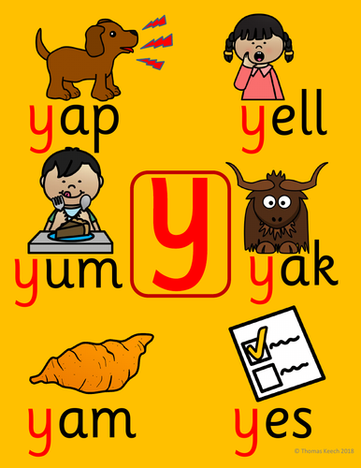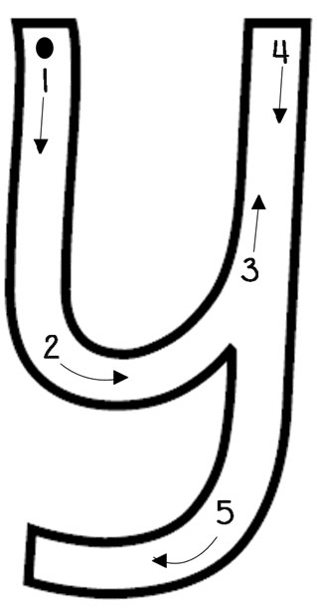  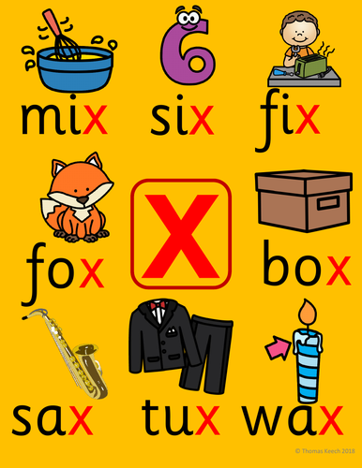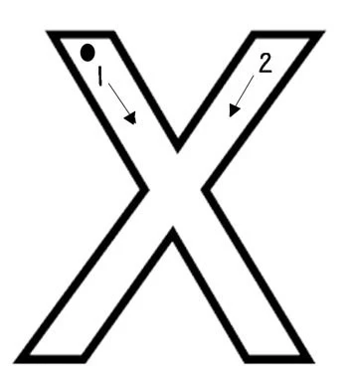  Spelling  We will be learning to spell the words:  she  come  from  Reading  Please spend some time reading and talking about your new reading book. Continue to learn your pink reading words off by heart. If you do know them, try making up your own sentences using the words. | Numeracy  We have started learning about length and we have been using the language of measure e.g shortest, longest, tallest, smallest, widest etc.  We have been learning to measure the length/height of objects using non-standard units (handspans, our feet, paper clips, cubes, blocks, pencils).  Choose a few objects to measure at home inside or outside using non-standard units.  Talk about:  Which object is the biggest?  Which is the smallest?  What do you notice about the number of handspans something is when an adult or a child measures something?  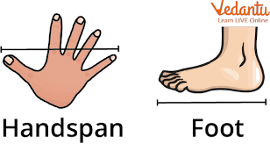  You could also have a go at measuring using measuring tools at home.  OR  Choose a couple activities to complete from the measuring grid on the homework page. | JRSO competition  Design a brightly coloured jacket for the JRSO road safety competition.  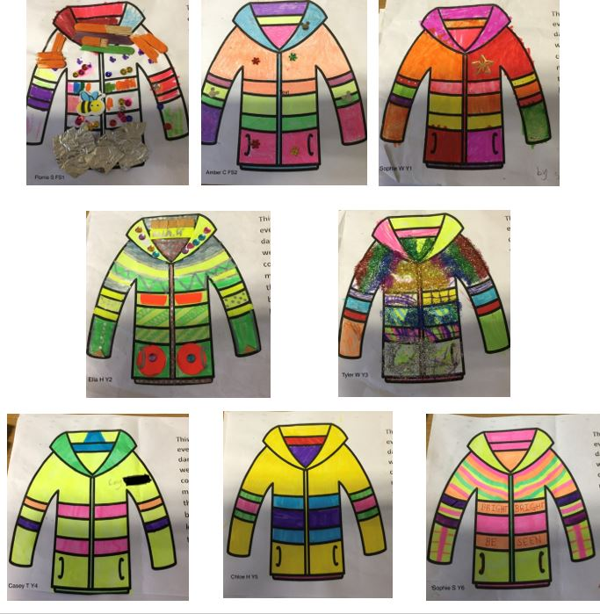  There will be a prize for 1st, 2nd and 3rd place. The JRSO committee will select the winners from Monday 25th March so please hand in your design to Miss Mair or Mrs Moir by 25/03/24.

