Primary 1 Learning Update 19.02.24
Literacy | Numeracy | STEM
Phonics  This week we will be learning the phonemes: z, w and ng. Talk about items you have at home or see outdoors that have the phonemes z, w and ng either at the beginning, middle or end of the word. Please practise writing the letters by starting and finishing at the correct places. You could use different coloured pencils, paints or chalk outside.  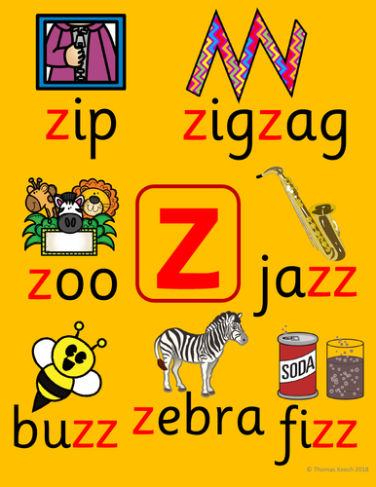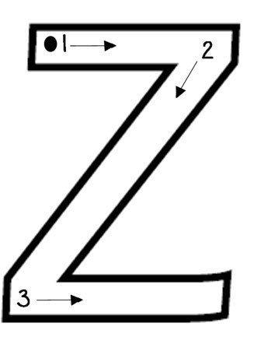  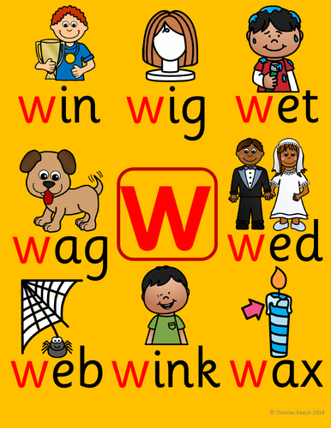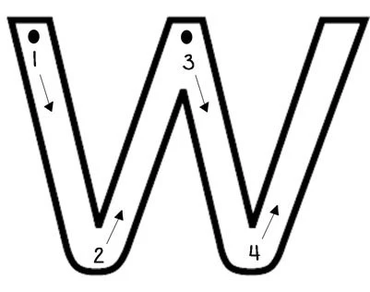  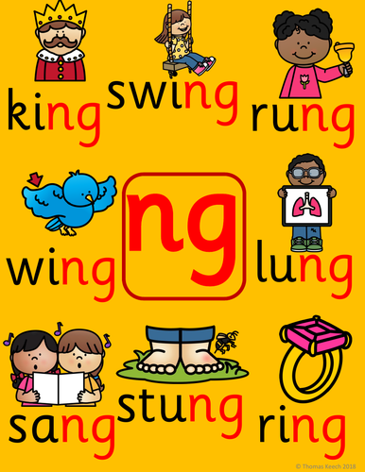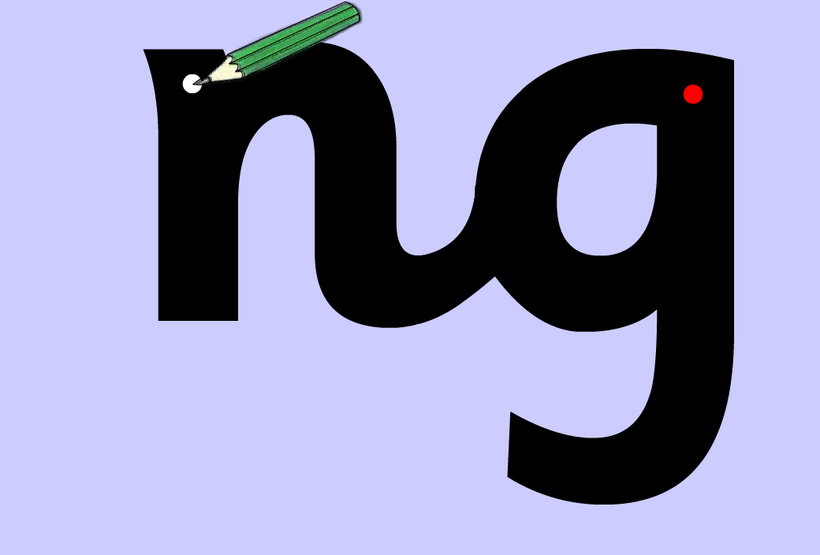  Spelling  We will be learning to spell the words:  - your  - only  - by  Reading  The children will be coming home with new reading words. Please try to learn them off by heart. | Numeracy In class we are consolidating the number stories up to 5.  The Number stories are all the calculations that make a quantity, e.g. the number story of 2 is: 2+0, 0+2 and 1+1. Try the game called ‘Ways to Make’ on Topmarks. Put the teddy bears into the houses to complete the addition calculations.  https://www.topmarks.co.uk/Flash.aspx?f=WaystoMake  Use toys at home to practise making the calculations of 2, 3, 4 and 5.  The game ‘Part-Part Whole’ may help. Click on ‘objects’ to use counters or cubes.  https://ictgames.com/mobilePage/partPartWhole/index.html  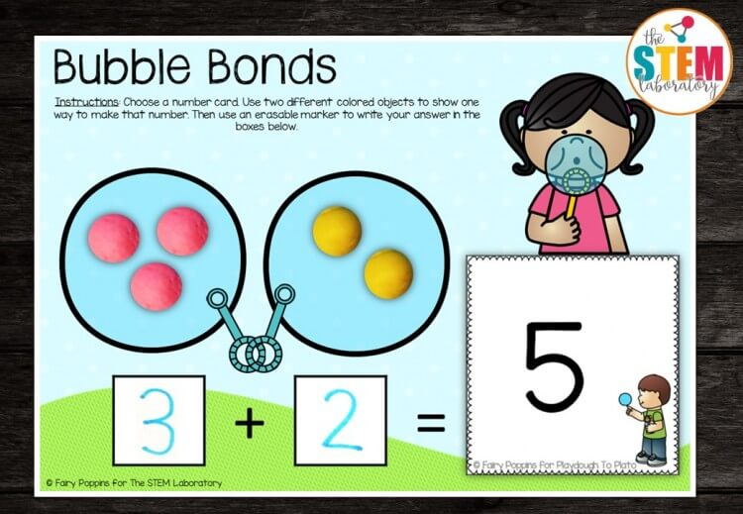 | STEM (Science, Technology, Engineering and Maths) Mascot competition.  - Design a mascot for our STEM room.  - Give your mascot a name and superpower. Remember to add your name and school.  - Please return to school by Monday 4th March 2024.  