Week beginning: 27.11.23 Primary 1
This is an update of some of our learning in Primary 1 this week.
Literacy | Numeracy | Health and Wellbeing
Phonics  We have been learning to recognise and read using phonemes. Phonemes are the sounds that make up words. We will be learning about G and O this week. Watch the video for each sound and try writing the letters at home.  Gg  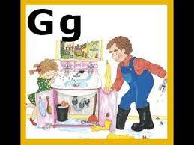  https://www.youtube.com/watch?v=7TLBk0OxOqc  Oo  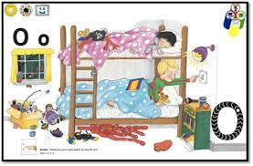  https://www.youtube.com/watch?v=y_LH4TN5xWk  Spelling  Our spelling words this week are – did, as, he  Reading  Continue to practise the pink reading words. Spend some time reading a book of your choice at home. | We have been building our confidence with counting items, matching quantities to numerals and ordering numbers.  We have been learning about combining two quantities and working out how many there are all together.  Practise counting and adding quantities together as much as possible at home to support the learning taking place in school.  Activity  Try playing Robot Addition on Topmarks. Your child can choose a level that suits them.  https://www.topmarks.co.uk/addition/robot-addition | If you have not had the chance to do so please check your Learning Journals this week for your child’s targets. Please talk with your child about their targets and add a Health and Wellbeing target to your profile.  If you have chosen a health and wellbeing target please spend some time working on your health and wellbeing target.  