Week beginning: 31.10.22 Primary 1
This is an update of some of our learning in Primary 1 so far.
Literacy | Numeracy | Health and Wellbeing
Phonics  We have been learning to recognise and read using phonemes. Phonemes are the sounds that make up words. This week is our consolidation week. We will be practising all of the phonemes covered so far: s, a, t, i, p, and n.  Please try the game called ‘SATPIN Sound Sort’. I have attached the file on the homework page of the P1 blog. Alternatively, talk about items at home or in the environment and discuss which phonemes they begin with.  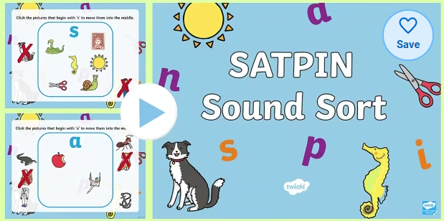  Reading.  Please continue to practise your yellow reading words.  Over the following days your child will come home with a login for Teach Your Monster to Read. The website is free to use on web browsers.  Spelling  During the consolidation week we will be practising spelling the words I, in, is, a, at, it. | We have been building our confidence with counting items, matching quantities to numerals and ordering numbers.  Activity  Try some of the games below.  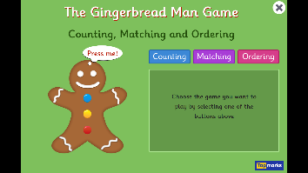  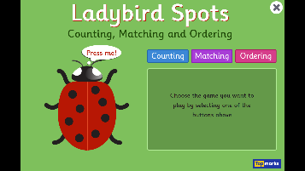  There are some other games on Topmarks to consolidate counting and ordering numbers.  https://www.topmarks.co.uk/maths-games/5-7-years/counting | During our PAThs lesson this week we will be learning about Twiggle making friends. Have a chat at home about how to make a new friend.  