Spelling List – Stage Six and Seven Common and Tricky Words
The following list contains words that are commonly misspelled by pupils at this stage/age group.
It is not intended as a ‘spelling list’ but it is recommended that pupils who can spell the common words from previous stages can then learn to spell the words from this list (that they don’t already know ).
absence | conscience | experience | priority | strategy
accommodation | conscious | explanation | primary | strength
ache | consequence | February | process | success
acquire | competition | fierce | proportion | surely
actually | convenience | finally | once | technique
advertise | chief | foreign | opposite | technology
again | continuous | forty | original | texture
aisle | cough | government | outrageous | though
alcohol | creation | grammar | parallel | tired
alliteration | daughter | guarantee | parliament | tomorrow
although | decide | guard | participate | unfortunately
analyse | decision | guess | pattern | vacation
analysis | definitely | happened | peaceful | vaccine
announcing | design | health | people | Wednesday
answer | desperate | height | performance | weight
anxious | develop | imaginary | permanent | weird
argument | development | imagine | persuade | women
assessment | dialogue | industry | persuasion | wreck
atmosphere | diamond | industrial | physical | wretched
audience | diary | inference | possession
autumn | difference | interesting | potential
awful | different | interrupt | primary
beautiful | disappear | issue | queue
becoming | disappearance | jealous | reaction
beginning | does | knowledge | receive
believe | doesn’t | library | reference
beneath | during | listening | relief
bizarre | educate | lonely | remember
breath | education | lovely | research
breathe | eight | marriage | resources
brilliant | either | material | safety
bury | embarrass | meanwhile | Saturday
buried | energy | miscellaneous | secondary
business | engagement | mischief | separate
busy | enquire | modern | sequence
ceiling | enthusiastic | murmur | shoulder
chocolate | environment | necessary | sincerely
climb | equipment | neighbour | skilful
column | especially | nervous | soldier
concentration | evaluation | nuisance | stomach
conclusion | evidence | preparation | straight

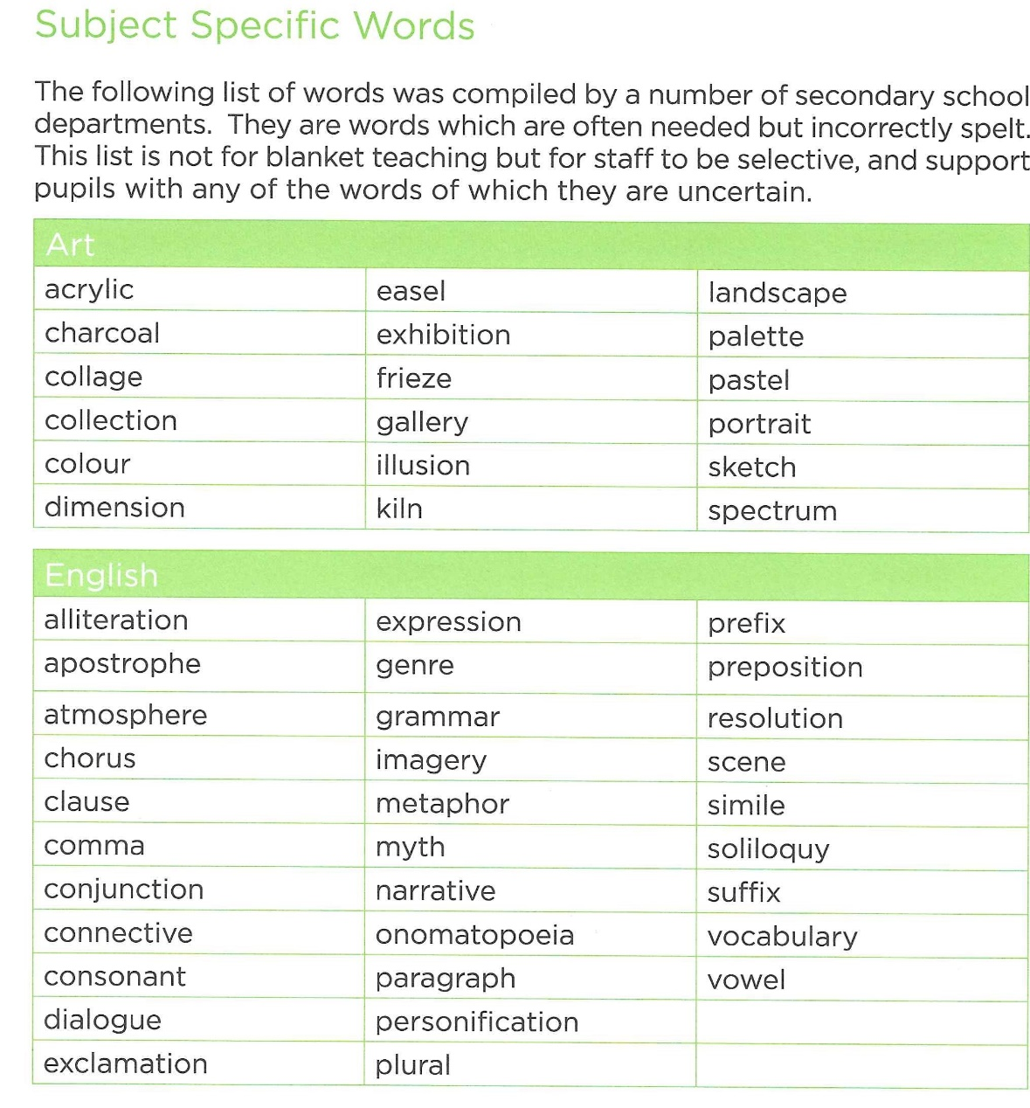
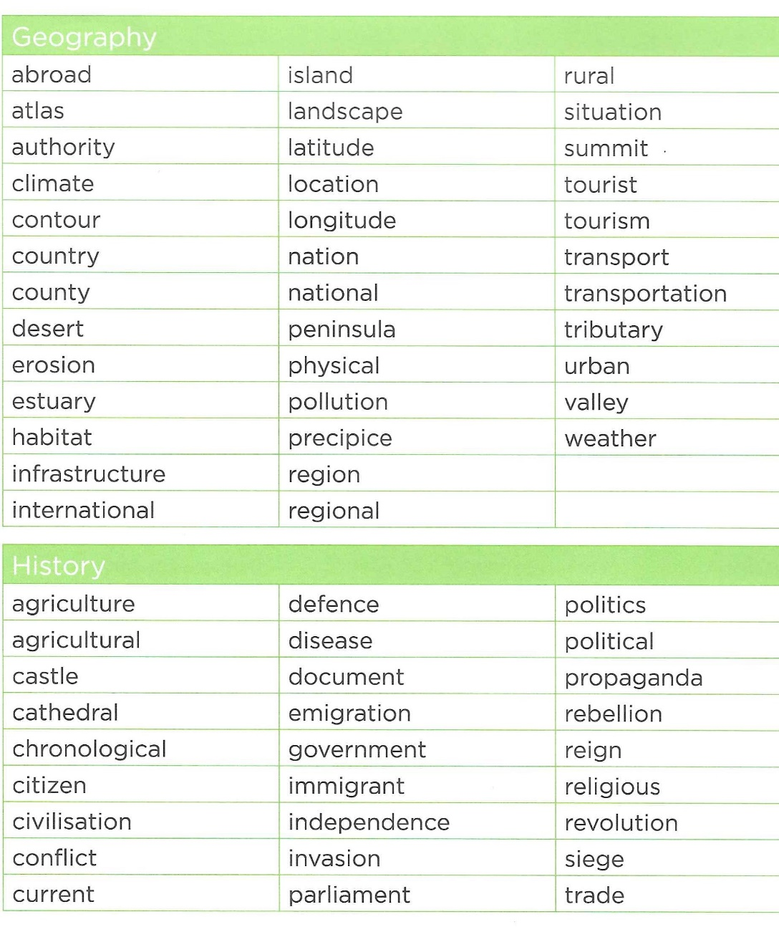
Stage Six and Seven Subject Specific Words

