In school your child learns to identify all 44 sounds we use in spoken English: phonemic awareness. We teach the letter/sound correspondences of the alphabetic code: phonics and the key skills of blending and segmenting.

Phonemic Awareness and Phonics

**Phonics**

Phonics is a method of teaching children to read by linking sounds (phonemes) and the letter symbols that represent them (graphemes) – the alphabetic code.

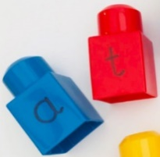

We can use our phonics knowledge to **encode**: spell words.

We can use our phonics knowledge to **decode**: read



**is the reverse of**

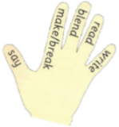



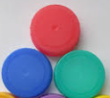

i

p

ch

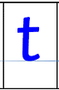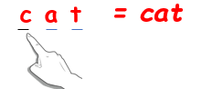

For **reading** we teach **blending**: *sound out and blend the sounds* all through the word (decoding)



Use bottle lids, bricks, plastic letters or letter cards to have fun making words. When *segmenting*, or breaking a spoken word into sounds, it helps to say the word slowly. Your child says all the sounds they hear in the word and can hold a finger up for each sound. They then choose the letters they need to make the word.

*chair = ch – ai – r*

For s**pelling** we teach **segmenting**: say the word, *sound out each of the sounds* to then match the letters we need to write it (encoding)

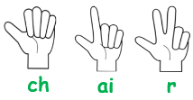

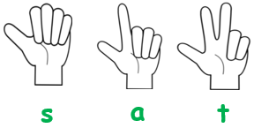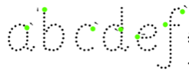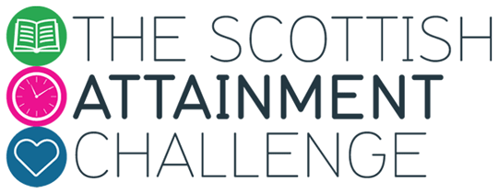

Your child learns how to **write** the letters (graphemes) as they are taught each sound (phoneme).

|  |  |  |  |  |  |  |
| --- | --- | --- | --- | --- | --- | --- |
| f | r | igh | t |  |  |  |

|  |  |  |  |  |  |  |
| --- | --- | --- | --- | --- | --- | --- |
|  |  |  |  |  |  |  |

|  |  |  |  |  |  |  |
| --- | --- | --- | --- | --- | --- | --- |
| sh | o | t |  |  |  |  |



* The Active Literacy Programme uses these terms*.

A **phoneme** is the smallest unit of sound in a word. Phonemes combine to make syllables and words. **Graphemes** are written /printed letters that represent the sounds in words. Phonemes can be represented by 1 – 4 letter graphemes: ‘b’, ‘g’, ‘sh’ ‘ai’ ‘igh’ ‘dge’ ‘ough’ ‘aigh’.

**Ask your child to explain how they use diacritical marking.**

In school your child will be using **diacritical marking** to investigate and record each sound /phoneme they hear in a word. They listen carefully and say the words accurately. (We start this at Stage 4.)

**Phonics – Diacritical Marking**

cup shark wing flash night stone

make please plate field bridge game

**Try using diacritical marking with the words below.**

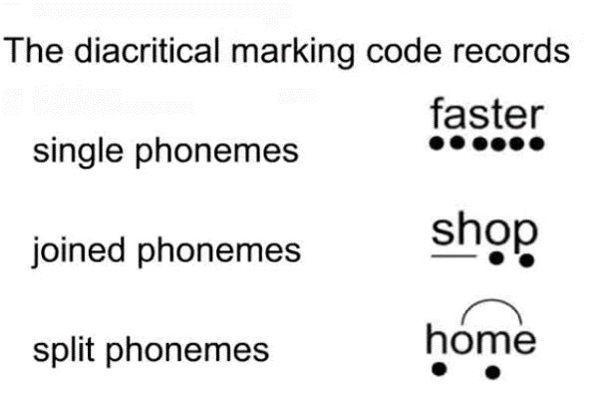

*

*

*

Try splitting or segmenting these words into sounds/ phonemes and fitting them into Elkonin boxes.

**Phonics – Elkonin Boxes**

In school your child will be using Elkonin boxes to investigate and record each sound/phoneme in a word.

Ask your child to explain how they use Elkonin boxes.

cup shark wing flash yesterday

house power window night cheese

|  |  |  |  |  |
| --- | --- | --- | --- | --- |
| **a** | **tap**  **t** | **sun**  **s** | **ink**  **i** | **p**  **pig** |
| **net**  **n**  **apple** | **r**  **red** | **map**  **m** | **dog**  **d** | **egg**  **e** |
| [Image result for cat clipart free](http://www.google.co.uk/url?sa=i&rct=j&q=&esrc=s&source=images&cd=&cad=rja&uact=8&ved=2ahUKEwiv5piGwtPZAhUIBcAKHbJDBRAQjRx6BAgAEAY&url=http://clipart-library.com/cat-clipart.html&psig=AOvVaw0vlcy_Nw7iUE_GBK2enYBf&ust=1520281995033021)  **cat**  **c** | **key**  **k** | [Related image](http://www.google.co.uk/url?sa=i&rct=j&q=&esrc=s&source=images&cd=&ved=2ahUKEwi5nI22wtPZAhXqLMAKHbqNDrsQjRx6BAgAEAY&url=http://clipart-library.com/gates-cliparts.html&psig=AOvVaw3IYEow7APAc8-JcTBgfA2t&ust=1520282104399197)  **g**  **gate** | [Image result for leg clipart free](http://www.google.co.uk/url?sa=i&rct=j&q=&esrc=s&source=images&cd=&cad=rja&uact=8&ved=2ahUKEwi2zsLuwtPZAhXsCsAKHU2tATcQjRx6BAgAEAY&url=http://www.clker.com/clipart-leg-2.html&psig=AOvVaw2d7GKzeOaqXrNZYG75zQdV&ust=1520282227928191)  **leg**  **l** | **f**  **fox** |
| **o**  **orange** | **bat**  **b** | **u**  **umbrella** | **hand**  **h** | **window**  **w** |
| **jam**  **j** | **v**    **van** | **y**  **yo-yo** | **z**  **zebra** | **x**  **box** |
| **qu**  **queen** |  |  |  |  |
| **a__e**  **flame** | **e__e**  **athlete** | **i__e**  **pine** | **o__e**  **cone** | **cube**  **u__e** |

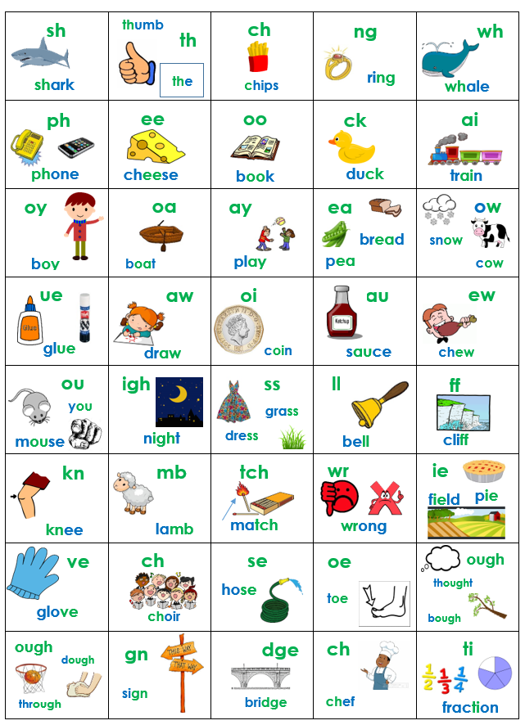



2+-letter graphemes – ‘Joined Phonemes’ *from Active Literacy Programme (in order they are taught)

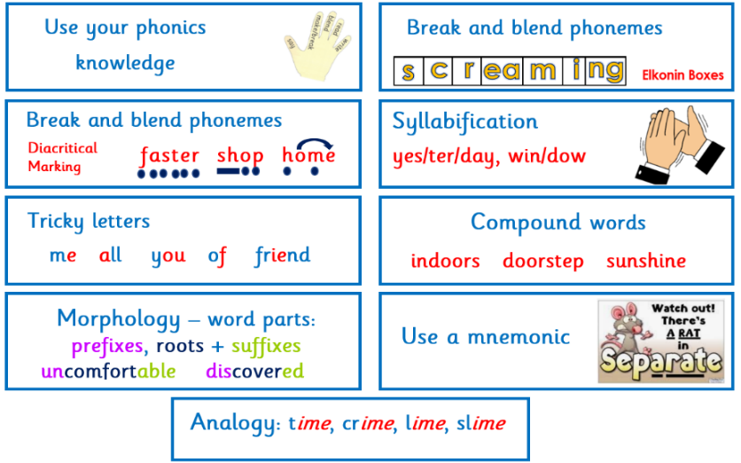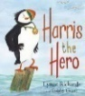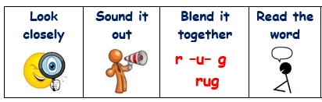

**Talk about it**

playground elephant because said shell they

Ask your child what strategy they would use to help them spell each word:

Using our phonics knowledge is the strategy we teach to spell words. There are many ways to spell some sounds e.g. play, sail, eight all have the /ay/ sound, and some letters represent different sounds e.g. cat, cell, so we continue to teach phonics code.

Your child learns some other strategies to spell common words that have tricky spellings e.g. *where, does, always*, or topic words e.g. *lighthouse.* Exploring patterns, ‘tricky bits’ and learning about the history of our words helps your child spell independently.

**Find it**

**Prove it**

What can you do to help?

Help your child develop their decoding and fluency skills by listening to them read their ‘reading book’. If they stick at a word, give praise for trying to ‘sound out’ the sounds in the word. If still stuck, you can give the word.

learning to read reading to learn.

But we also develop **comprehension** by reading, watching and listening to a range of other texts. This helps develop vocabulary and knowledge.

To begin with, children will have books to help them learn to **decode** and become fluent readers. Decoding is taught using phonics.

**Learning to read**

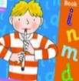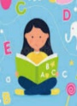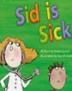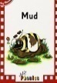

Reading can be broken into two main parts:

**DECODING** and **COMPREHENSION**.

**Decoding** is how we ‘lift the words off the page’ to be able to read them. **Comprehension** is understanding the words.

**Reading**

**Spelling Strategies**

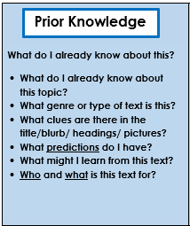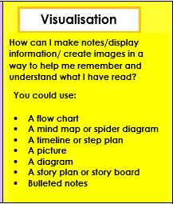

**Active Literacy Comprehension**

**Strategies**

**Find it**

**Prove it**

**Talk about it**

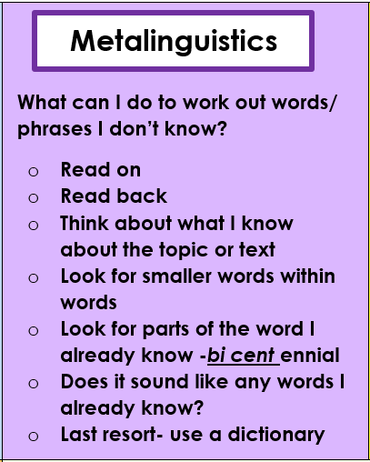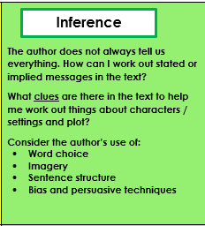

**Active Literacy Comprehension**

**Strategies**

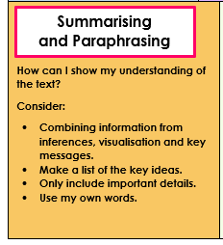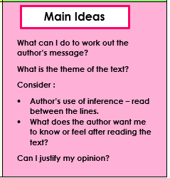

**ch**

**i**

**p**

**What is phonics?**

With phonics, children are taught to read by learning the phonemes (sounds) that represent letters or groups of letters (graphemes). Children can then begin to read words by learning how to blend the sounds in words. Unlocking how the alphabetic code works means they can learn to decode any word. For example, when taught the sounds /t/, /p/, /a/, /i/ and /s/, children can read words such as *it, is, tap, tip, pat, sip* and *sat* by blending the sounds together to make the word.

These words can also be broken down (segmented) into phonemes for spelling. The word ‘sat’ has three phonemes, /s/, /a/ and /t/ which children learn to write with the three letters ‘s’, ‘a’ and ‘t’ that they have learned.

They will also be taught to read words such as ‘once’, ‘was’ or ‘have’ – for which they don’t yet have the phonics knowledge. We need these common words for our reading and writing. We still use our phonics knowledge, but the teacher will point out any tricky part – e.g. the ‘e’ in ‘me’ represents the /ee/ sound.

Say the sounds correctly. It’s important that the sounds are pronounced correctly, as they would sound in speech. Try not to add ‘uh’ to consonant sounds, such as /t/ and /p/, as this makes it trickier to blend the sounds together into words.

Link sounds and letters to make words. In school, children are learning to link the sound with the written representation of that sound (grapheme). Encourage your child to do the same when playing with fridge magnets in the kitchen for example, or ‘writing’ when you are writing.

Make it fun! Simple games such as ‘I spy’ are great for helping to read, because children have to listen to sounds. Say, “I spy, with my little eye, something that begins with the sound ‘f-f-f’. Make sure you refer to the first ‘**sound**’ e.g. ‘ch’ for chair or ‘f’ not ‘p’ for phone.

Practise! Encourage your child to use their phonic knowledge when they are practising their reading. Make sure that they look at each letter in turn, all through each word. Encourage them to work out the sounds and then blend them together to make the word. Praise them for trying to use all the letters -**not guessing** from the first letter or the picture. If your child cannot get the word by ‘sounding out’, you can tell them the word.

**igh**

**f**

**l**

**t**

**a**

**b**

**ee**

**sh**

**Reading – how you can help at home**

Reading aloud to your child, talking about the words and pictures, and sharing ideas about the book.

Reading yourself: Children who see adults reading, and enjoying reading, are much more likely to want to read themselves.

Most importantly, **talk** with your child. Spend time with them doing simple activities (cooking, making something, building a model). As you talk about what you’re doing, you are helping them to learn new words. Later, when they see words written down, they have already heard them and know what they mean.

Have a regular time for reading so reading becomes a habit.

