Primary 2 week beginning 24.1.2022
Spelling words:  revision week  blue best number other  what soon many book | Phoneme: revision week oo or ew or ue  aw or au  Can you find these sounds in a book, newspaper or a recipe? | Ways to make the number:  39 and 40
Money:
I can identify all coins up to 20p.
I can use coins to at least 20p to pay for items.
https://www.topmarks.co.uk/money/toy-shop-money

Paths  “Sharing is Caring”  It is a win win situation! | 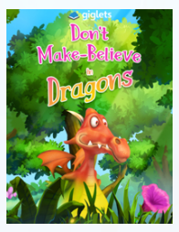  Literacy This month we will be focusing on the Scots language!  Reading :  LOG ONTO GIGLETS!  I have left a job there for you!  www.giglets.com
Just thought you would like to know about some of the work we will be covering this week in class. It would be really helpful if you could go over spelling words, our phoneme and some number facts.

