Primary 2 week beginning 17.1.2022
Spelling words:  hand  who  after  right | Phoneme:  igh  as in night  Try out studyladder! | Ways to make the number:  37 and 38
Money:
I can identify all coins up to 20p.
I can use coins to at least 20p to pay for items.
https://www.topmarks.co.uk/money/coins-game
Paths  “Sharing is Caring”  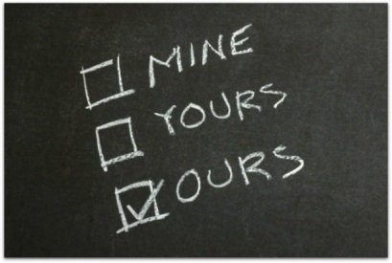  It is a win win situation! | 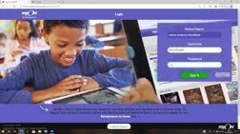  Literacy  Reading : Log on and choose a book !  https://www.myon.co.uk/login/  This month we will be focusing on the Scots language!  LOG ONTO GIGLETS!  I have left a job there for you!  www.giglets.com
Just thought you would like to know about some of the work we will be covering this week in class. It would be really helpful if you could go over spelling words, our phoneme and some number facts.

